Alcohol
&
Substance
Abuse
Prevention
Project

Orientation Manual

Contents
Welcome 3
Words from the Director 3
Overview 4
Department of Behavioral Health Developmental Disabilities Overview 4
Divison of Behavioral Health Overview 5
Office of Behavioral Health Prevention Overview 6
Office of Behavioral Health Prevention Organizational Chart 7
Staff Directory 8
Administrative Staff 9
ASAPP Regional Prevention Staff 10
Regional Prevention Specialist – Region 1-3 10
Regional Prevention Specialist – Region 4-6, RPS Supervisor 11
Suicide Prevention Staff 12
Prescription Drug Staff 12
SYNAR Coordinator 12
Financial Staff 12
Data Analyst 12
ASAPP 13
Overview 14
Deliverables 16
Allowable and Unallowable Costs 20
Forms 25
Monthly Income and Expenditure Report 26
Monthly Budget Narrative 27
Monthly Programmatic Report 28
Implementation Plan 34
Budget Adjustment Form 35
Creatives Approval Form 36
Technical Assistance 37
Evaluation 38
Resources 39
All Resources 40

Welcome

Words from the Director
I’d like to congratulate you all on becoming contracted community substance abuse providers for the Georgia Department of Behavioral Health and Developmental Disabilities’ (DBHDD) Office of Behavioral Health Prevention (OBHP). Welcome to the 2017 Alcohol and Substance Abuse Prevention Project (ASAPP). We’re excited to have you on board and are looking forward to developing a close and successful working relationship.

ASAPP is funded by the Substance Abuse and Mental Health Services Administration’s (SAMHSA) Mental Health Block Grant. Using the Strategic Prevention Framework (SPF) and evidenced-based strategies, this project leverages community substance abuse prevention providers to address one of Georgia’s priority alcohol goals and a secondary substance abuse goal. The secondary substance abuse goal can be another of Georgia’s identified alcohol goals or a substance abuse goal identified by a local community and substantiated by data.

Through ASAPP, together we will identify and document the provision of culturally appropriate prevention strategies that best fit and are most effective with the differing populations we serve. Your role in effectively implementing and documenting these strategies within the communities is vital to this process. Based on your information, we will evaluate the strategies used within the differing communities and use the results to enlighten decisions for future efforts.

We appreciate your devotion to the prevention field and your commitment to undertake this ASAPP contract. This manual is intended to orient you to the Alcohol and Substance Abuse Prevention Project, and provide you with the pertinent information and resources to help you meet your contracted responsibilities. Additionally, you can contact your assigned Regional Prevention Specialist (RPS) or contact anyone in our OBHP office for additional information.

Warm Regards,

Travis L. Fretwell
Director of the Office of Behavioral Health Prevention

Department of Behavioral Health and Developmental Disabilities Overview

The Georgia Department of Behavioral Health and Developmental Disabilities (DBHDD) provides treatment and support services to people with mental health challenges and substance use disorders, and assists individuals who live with intellectual and developmental disabilities.

DBHDD Vision:
Easy access to high-quality care that leads to a life of recovery and independence for the people we serve.

DBHDD Mission:
Leading an accountable and effective continuum of care to support Georgians with behavioral health challenges, and intellectual and developmental disabilities in a dynamic health care environment.

DBHDD Organizational Chart
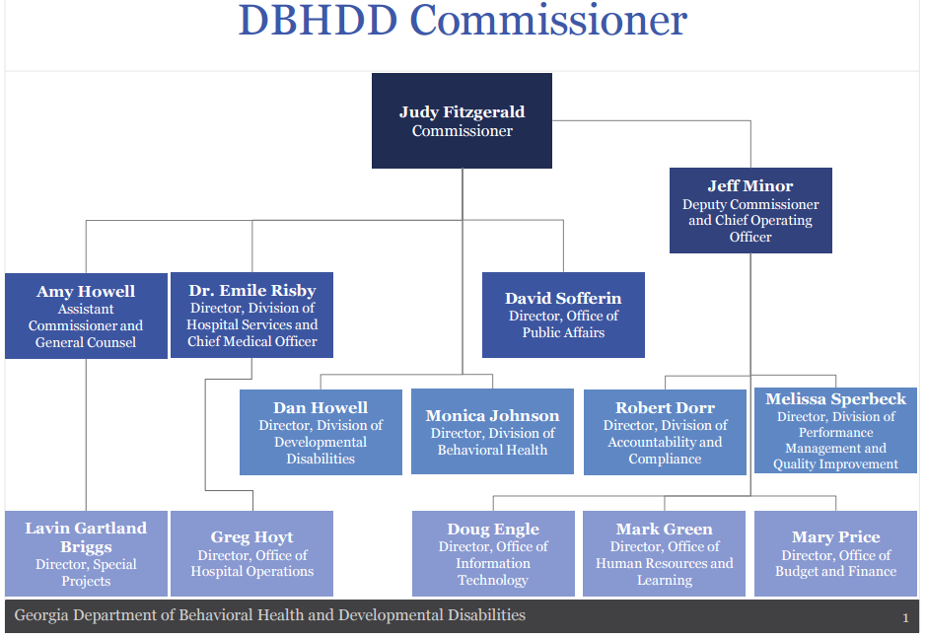
http://dbhdd.georgia.gov/about-dbhdd
For information on DBHDD’s Organizational Charts visit: https://dbhdd.georgia.gov/sites/dbhdd.georgia.gov/files/related_files/site_page/DBHDD%20Org%20Charts%201.26.17.pdf
Division of Behavioral Health Overview
The Division of Behavioral Health (DBH) serves individuals in their own communities, offering high-quality services and supports through an array of comprehensive and specialty services. The division maintains a statewide service delivery system for the treatment of mental illness and emotional disturbance in adults and youth with a focus on recovery through community-based care, providing appropriate levels of service in the least restrictive setting possible.
DBH Organizational Chart
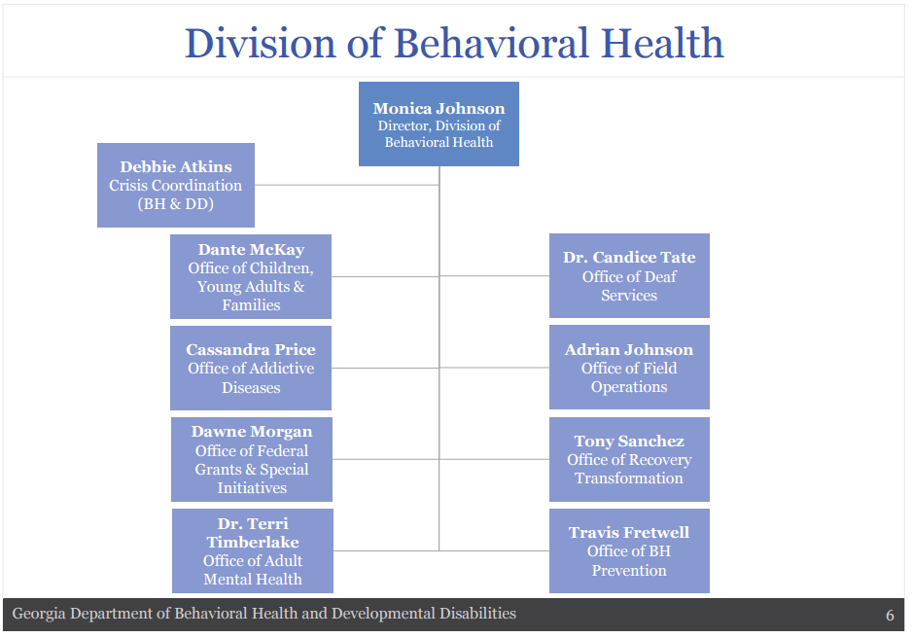

http://dbhdd.georgia.gov/behavioral-health
Division Director: Monica Johnson, LPC
Contact Information: monica.johnson@dbhdd.ga.gov
Office Phone Number: 404-651-852
Office of Behavioral Health Prevention Overview

The Georgia Office of Behavioral Health Prevention (OBHP) is the state agency charged with providing leadership, strategic planning, and services to improve the mental/emotional well-being of communities, families, and individuals in Georgia.

In 2015 the OBHP was reorganized to include suicide prevention and mental health promotion, along with substance abuse prevention. Historically, behavioral health had focused on the prevention of single, separate disorders. Current research shows that substance abuse and other behavioral health problems—such as psychological distress and suicide—are interrelated and can be addressed at the same time. They share common risk and protective factors. Improvements in one area often directly affects others.

The OBHP develops and contracts for prevention services across the state specifically designed to reduce the risks and increase protective factors linked to substance-abuse-related problem behaviors, suicide, and mental health promotion.
Substance Abuse Prevention
Suicide
Prevention

Mental
Health
Promotion

OBHP Mission:
To lead and support a comprehensive data driven strategic plan for assisting communities in developing, implementing, and evaluating proactive evidence based strategies in their communities that promote well-being and healthy behaviors and lifestyles.
Mental Health
Promotion

OBHP Vision:
For all Georgians to live in communities that promote, support and reinforce healthy behaviors, lifestyles, and the well-being of its citizens.

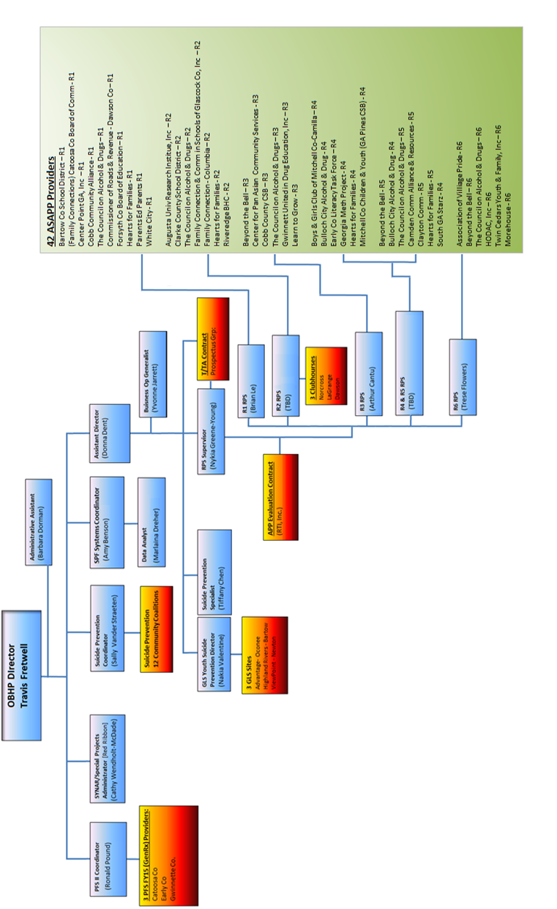
OBHP Organizational Chart
(updated 4/10/2017)

Staff Directory

This section includes:
Administrative Staff
ASAPP Regional Prevention Staff, ASAPP RPS Supervisor
Suicide Prevention Staff
Prescription Drug Staff
SYNAR Coordinator
Financial Staff
Data Staff

Administrative Staff

Director
Name: Travis Fretwell
Email: Travis.Fretwell@dbhdd.ga.gov

Assistant Director
Name: Donna Dent
Email: Donna.Dent@dbhdd.ga.gov

Assistant to Director
Name: Barbara Dorman
Email: Barbara.Dorman@dbhdd.ga.gov

Strategic Prevention Framework Coordinator
Name: Amy Benson
Email: Amy.Benson@dbhdd.ga.gov

ASAPP Regional Prevention Staff

Regional Prevention Specialist – Region 1
Name: Brian Le
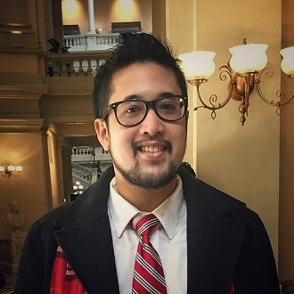
Email: Brian.Le2@dbhdd.ga.gov
Number: 404.657.2165

Brian Khang Le is the Region 1 prevention specialist for OBHP. He was formerly the alcohol prevention program coordinator for the Center for Pan Asian Community Services. Brian has worked in international tobacco control and research at the American Cancer Society (focusing on tobacco prevention in Sub-Saharan Africa under funding from the Bill and Melinda Gates Foundation), and patient quality improvement in Grady Health’s Marcus Stroke & Neuroscience ICU. He has a studied exercise physiology, genetics, and biochemistry at UCLA, where he graduated with a bachelor of science in biochemistry. He also holds a master of public health in health policy and management from the Rollins School of Public Health at Emory University.

Regional Prevention Specialist – Region 2
Name: Aliza Petiwala
Email: Aliza.Petiwala@dbhdd.ga.gov
Number: 404.657.2134

Before joining the DBHDD team, Aliza Petiwala was a program coordinator for a state-funded initiative to improve substance use programming in South Carolina. While working with this initiative, she developed an appreciation for impactful behavioral health research and programming. Aliza’s background is in research and evaluation, and she previously spent two years volunteering with the Peace Corps in the Republic of Palau as a teacher. She holds master’s degrees in both social work and public health from the University of South Carolina.

Regional Prevention Specialist – Region 3
Name: Art Cantu
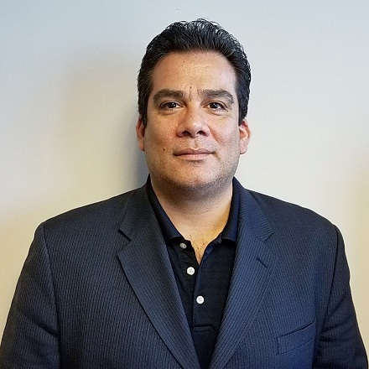
Email: Arthur.Cantu@dbhdd.ga.gov
Number: 404.657.2362

Arthur Cantu is the Region 3 prevention specialist for OBHP. He was formerly the alcohol prevention coordinator for CETPA. Art has worked the past 10 years in the non-profit field and in banking for 10 years prior to that. Art was a student athlete at the University of North Carolina-Charlotte, where he graduated with a bachelor’s in Spanish. Art is also fully bilingual in Spanish and holds a translating certificate for education.

Regional Prevention Specialist – Region 4 & 5
Name: Nia Sutton
Email: Nia.Sutton@dbhdd.ga.gov
Number: 404.657.2259

A native of Washington, DC, Nia Sutton acquired her passion for prevention work at the young age of 16, after landing her first job as a peer educator. Following this passion, Nia went on to pursue public health education at North Carolina Central University. There, her interests in alcohol and substance abuse prevention spiked while interning in the Office of Health Promotion at Wake Forest University.

When Nia completed her undergraduate studies, she began her professional career path as a public health educator at a rural, local health department in North Carolina. With the desire to further her education and learn more about prevention, Nia decided to relocate to Atlanta, where she is currently matriculating through the Master of Public Health program at Georgia State University. Nia joined the DBHDD team in January 2017 as the regional prevention specialist for Regions 4 and 5.

Regional Prevention Specialist – Region 6
Name: Trese Flowers
Email: Trese.Flowers@dbhdd.ga.gov
Number: 404.657.5737

Trese Flowers is the regional prevention specialist for Region 6. In her role, Trese works closely with contracted community providers to build relationships and develop plans to implement prevention strategies. Working with the providers in the community what she loves about this position. Trese is a 2001 graduate of Xavier University with a bachelor of science in Biology. She obtained her master of public health with a concentration in community health from Mercer University School of Medicine in 2003. Currently, she is pursuing a doctorate in public administration from Valdosta State University, with an anticipated graduation of May 2018. Additionally, she holds various professional certifications that aid in her career. Trese is an avid reader in her spare time and she also enjoys live music performances.

Regional Prevention Specialist Supervisor
Name: Nykia Greene-Young
Email: Nykia.Greene-Young@dbhdd.ga.gov
Number (Office): 404.463.6441
Number (Cell): 404.304.1391

Nykia Greene-Young is the regional prevention specialist supervisor for OBHP. She was formerly the regional prevention specialist for Region 3. She has worked in the fields of prevention and in public policy for several years. She holds a master’s in political science from Clark Atlanta University.

Prescription Drug Staff

Gen RX Coordinator
Name: Ron Pounds
Email: Ronald.Pounds@dbhdd.ga.gov

SYNAR Coordinator

SYNAR Coordinator
Name: Cathy Wendholt-McDade
Email: Cathy.Wendholt-Mcdade@dbhdd.ga.gov

Suicide Prevention Staff

Garrett Lee Smith Coordinator
Name: Nakia Valentine
Email: Nakia.Valentine@dbhdd.ga.gov

Suicide Prevention Coordinator
Name: Sally vander Straeten
Email: Sally.vanderStraeten@dbhdd.ga.gov

Suicide Prevention Specialist
Name: Tiffany Chen
Email: Tiffany.Chen@dbhdd.ga.gov

Financial Staff

Billing
Name: Yvonne Jarrett
Email: Yvonne.Jarrett@dbhdd.ga.gov

Data Staff
Data Analyst
Name: Marlaina Dreher
Email: Marlaina.Dreher@dbhdd.ga.gov

ASAPP

This section includes:
Overview of the Alcohol and Substance Abuse Prevention Program
Deliverables
Allowable and Unallowable Costs

Overview

Alcohol and Substance Abuse Prevention Project
The Alcohol and Substance Abuse Prevention Project (ASAPP) is a substance abuse prevention initiative of the Georgia Department of Behavioral Health and Developmental Disabilities’ (DBHDD) Office of Behavioral Health Prevention (OBHP). This project is implemented using the Substance Abuse and Mental Health Services Administration’s (SAMHSA) Strategic Prevention Framework (SPF).
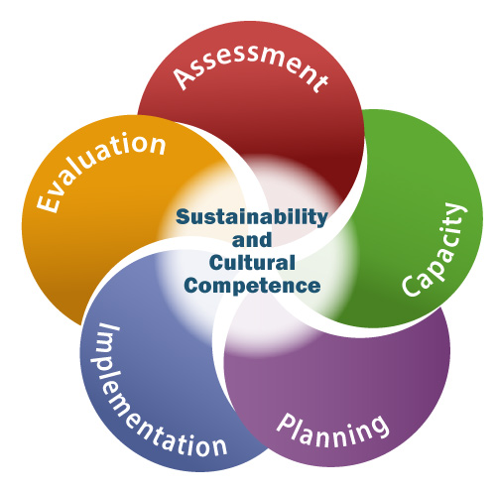
SPF is a five-step methodology that incorporates sustainability and cultural competence throughout the various steps of assessment, capacity building, planning, implementation, and evaluation. Using evidence-based individual and environmental strategies, a strategically developed workforce, and communal collaborative efforts, the contracted agencies will create lasting change in the communities served.
Georgia’s statewide initiative assessment data was used to identify early onset of alcohol use, abuse, and binge drinking as an ongoing major public health issues in the state. Based on Georgia’s data, ASAPP will target three statewide goals:
- Reduce the early onset of alcohol use among 9-20 year olds.
- Reduce access to alcohol and binge drinking among 9-20 year olds.
- Reduce binge & heavy drinking among 18-25 year olds.
ASAPP grew out of the Alcohol Prevention Project (APP), which began in 2011 and also used SPF. Expanding beyond alcohol prevention efforts in APP, ASAPP allows communities to also address a secondary high priority substance of abuse and misuse identified through assessment data. This approach will result in building communities’ capacity to find and use data and develop and implement strategic plans for sustainable outcome-based prevention strategies.

Funding Source:
Funding for ASAPP is provided by SAMHSA’s Substance Abuse Prevention and Treatment Block Grant (SABG) program. SABG provides funds to all 50 states, the District of Columbia, Puerto Rico, the U.S. Virgin Islands, six Pacific jurisdictions, and one tribal entity, to prevent and treat substance abuse.
The SABG program’s objective is to help plan, implement, and evaluate activities that prevent and treat substance abuse. SAMHSA's Center for Substance Abuse Treatment’s (CSAT) Performance Partnership Branch, in collaboration with the Center for Substance Abuse Prevention’s (CSAP) Division of State Programs, administers the SABG.
As an SABG grantee, Georgia must:
- Have a designated unit of its executive branch that is responsible for administering the SABG (for example, Division of Behavioral Health) work with the grantee’s department of health
- Apply annually for SABG funds
- Have the flexibility to distribute the SABG funds to local government entities, such as municipal, county, or intermediaries, including administrative service organizations
- Have SABG sub-recipients, such as community- and faith-based organizations (non-governmental organizations), and deliver:
- Substance abuse prevention activities to individuals and communities impacted by substance abuse
- Substance use disorder (SUD) treatment and recovery support services to individuals and families impacted by SUDs
More information about the SAMHSA Substance Abuse Block Grant can be found at https://www.samhsa.gov/grants/block-grants/sabg

Deliverables

Alcohol and Substance Abuse Prevention Project (ASAPP)
Substance Abuse Prevention Contract Deliverables

Agency Staffing
- Identify, hire, and maintain an ASAPP program coordinator (full time strongly preferred) who will:
    - Participate in all required meetings, trainings, and calls (including a 4-day SAPST Training).
    - Ensure that your organization/agency will meet deliverables set forth in the contract.
- Submit an updated organizational chart (agency, organization) within 30 working days of contract initiation.
    - If any agency staffing modifications occur during the contract period, submit an amended organizational chart with up-to-date contact information (with résumés and start and end dates within 30 days of modification).
- Submit an ASAPP staffing chart within 30 working days of contract initiation. Provide a detailed description of the roles and responsibilities of each staff member working on the ASAPP project.
    - If any ASAPP staffing modifications occur during the contract period, submit an amended staffing chart and justification with up to date contact information within 30 days of modification).
- All agency staff (including school staff) assigned to work on the ASAPP and paid with funds from this contract are expected to work the entire 12-month period of this contract.
- Provide RPS/OBHP with new employee orientation material pertaining to ASAPP.

Programmatic and Financial Reporting
- Submit the monthly progress report (MPR), monthly expenditure report, and monthly budget narrative to the regional prevention specialist (RPS), by the fifth working day each month, including any additional supporting documents.
- MPR must provide a detailed narrative of all the work produced for each strategy being implemented.
- Any changes to the approved budget line items must be pre-approved by the RPS.
- Electronically submit process and outcome data and adhere to all specified timeline/deadlines for data entry. This includes, but is not be limited to annual evaluation reporting and the state’s designated reporting system.
- Submit any additional reports and/or documents requested by Office of Behavioral Health Prevention (OBHP) by designated deadlines.
- All requests for programmatic changes such as strategy changes must be submitted in writing to the OBHP for approval prior to implementing.
Coalition and Community Prevention Alliance Workgroup (CPAW) Development
- Maintain participation in a local coalition that supports the goals of the ASAPP. Provide documentation of this partnership; Memorandum of Understanding (MOU), memorandum of agreement (MOA), and/or cooperative agreement (CA) will suffice. Additionally, provide documentation of your participation in the coalition (MPR).
- Maintain and expand the Community Prevention Alliance Workgroup (CPAW), which will consist of the following three sub-workgroups:
    - Epidemiological/Data Workgroup
    - Planning and Operational Workgroup
    - Evaluation and Sustainability Workgroup
- Submit all partnership agreements (MOU, MOA, CA) for the CPAW within 30 days of contract initiation. If new partnerships develop, submit the proper documentation within 30 days. If partnerships are terminated, notify OBHP within 30 days.
- Submit a CPAW membership roster with defined roles and responsibilities within 30 days of contract initiation. If any modifications occur, submit updates within 30 days.
- Required to conduct a monthly CPAW meeting.
- Report CPAW achievements.

Staff Development, Training, & Continuing Education
- Program coordinator must attend all required trainings/conferences related to the ASAPP, which will be defined by OBHP.
- Program coordinator or pre-approved designee must attend and participate in mandatory regional provider meetings.
- Provider staff will actively participate in all trainings, clinics, and technical assistance (TA) sessions with the RPS and state identified contractors.
- A minimum of one ASAPP programmatic staff will work toward becoming credentialed through the Prevention Credentialing Consortium of Georgia at the level of prevention apprentice or above. Submit verification of prevention certification to the RPS via the MPR.
- All training paid for with ASAPP funding will need to be approved by your RPS prior to attendance.
- If ASAPP funding is used to attend a Training of Trainers (TOT), and the provider is going to offer this training to outside agencies, fellow ASAPP providers must not be charged more than a nominal registration fee to cover minimum costs (i.e. training materials). In addition, the training must be approved by the Office of Behavioral Health Prevention staff.
- A minimum of one ASAPP programmatic staff from your agency/organization must attend at least one state or national conference designated or approved by OBHP.
- Contractor is required to provide orientation (including SPF and strategy) on the project and initial TA for new employees.

Miscellaneous Contract Requirements
- Participate in Georgia Red Ribbon Week substance abuse prevention related activities and submit information via MPR describing participation.
- Develop or revise existing agency/organization website to include information related to Alcohol and Substance Abuse Prevention Project (ASAPP). Maintain and update website and include noted changes in corresponding MPR.
- Screen for tobacco during individual strategies or when coming in contact with individuals in the community. Provide information to individuals on the dangers of tobacco, cessation counseling, quit lines, etc., and give referrals and resource recommendations. Interventions such as or similar to 2As & R The Brief Tobacco Intervention; Ask, Advise, Connect/Refer (i.e. CDC site: https://sacks.cdc.gov.ga/view/29959). Each intervention must be preapproved by OBHP.

Assessment
- Submit, maintain, and provide to OBHP all documentation and data per the needs assessment phase.

Capacity Building
- Submit, maintain, and provide to OBHP all documentation and data per the capacity building phase.
- Submit community readiness, process, and deadlines to be determined by OBHP (within the first contract year).

Strategic Planning
- Submit, maintain, and provide to OBHP all documentation and data per the strategic planning phase.
- Submit, review, and update strategic plan, as needed.

Implementation
- Submit, maintain, and provide to OBHP all documentation and data per the implementation phase.
- Implement approved strategies aligned with designated goals per OBHP approved strategic and implementation plans.

*Modifications to the approved strategic and implementation plans and selected strategies must be preapproved by OBHP.

Evaluation
- a. Submit and provide evaluation plan and documents for local evaluation.
b. Submit and provide documentation and data for the statewide evaluation.
- Maintain all documentation and data per the evaluation phase.
- Maintain a local program evaluator who will attend and participate in all required meetings, trainings and ensures that agency/organization meets evaluation deliverables (e.g., evaluation plan and data collection tools).
- Participate and complete state evaluation activities (e.g. pre/post-implementation assessments, site visits, and interviews) as directed by the state evaluator and the state contracted evaluation team.
- Submit all requested tools and documents related to both local and state evaluation of project activities, including, but not limited to, monthly surveys and ad-hoc assessments.

Sustainability/Cultural Competency
- Program coordinator will attend and actively participate in all required sustainability training and submit a sustainability plan (within the first contract year).
- Program coordinator will attend required and actively participate in all cultural competency trainings.

*The sustainability plan may be a component of the annual report as well.
This contract period begins the 15th day of November, 2016 and ends the 30th day of September, 2017. The contract’s deliverables shall be undertaken and completed within the contracts’ 10.5 month contract period, not 12 months.

Allowable and Unallowable Costs

Georgia Department of Behavioral Health & Developmental Disabilities
(DBHDD)/Office of Behavioral Health Prevention (OBHP)
Allowable & Unallowable Expenses for Providers

The Federal Substance Abuse Prevention and Treatment Block Grant (SAPT-BG) funds development and implementation of substance abuse prevention and treatment policies, practices, and programs. The SAPT-BG funds ASAPP and the Georgia Strategic Prevention System (GASP) initiative; therefore, the criteria for determining how to spend these federal dollars are dictated by federal and DBHDD/OBHP requirements.

All reimbursed activities must relate directly to the contract deliverables and the current stage of the ASAPP initiative (e.g., a provider may not charge for the implementation of services/activities when the initiative is in the capacity building stage).

The following sections provide principles to be applied in establishing the allowability or unallowability of certain items of cost.

Advertising costs.

- The term advertising costs means the costs of advertising media and corollary administrative costs.
- The only allowable advertising costs are those which are solely for:
(1) The recruitment of personnel required for the performance by the contracted provider.
- Unallowable advertising and public relations costs include the following:
(3) Costs of promotional items and memorabilia, including models, gifts, and souvenirs;
(4) Costs of advertising and public relations designed solely to promote the DBHDD contractor.

Alcoholic beverages. Costs of alcoholic beverages are not allowable.

Audit costs and related services. The costs of audits required by, and performed in accordance with, the Single Audit Act, as implemented by OMB Circular A-133, "Audits of States, Local Governments, and Non-Profit Organizations," and DBHDD contracts are allowable.

Per Diem/Fees/Contracts

- Professional service costs. Costs of professional and consultant services rendered by persons who are members of a particular profession or possess a special skill, and who are not officers or employees of the contracted provider, are allowable when reasonable in relation to the services rendered.

- In determining the allowability of costs in a particular case, no single factor or any special combination of factors is necessarily determinative. However the following factors are relevant:
- The nature and scope of the service rendered in relation to the service required.

- The necessity of contracting for the service, considering the DBHDD provider’s capability in the particular area.

- Whether the service can be performed more economically by direct employment rather than contracting.

Communication costs. Costs incurred for telephone services, local and long distance telephone calls, postage, electronic or internet services, and the like are allowable.

Compensation for personal services.

- Compensation for personnel services includes all remuneration, paid currently or accrued, for services rendered during the period of performance under DBHDD contract, including wages, salaries, and fringe benefits. The costs of such compensation are allowable to the extent that they satisfy the specific requirements of the DBHDD contract.

- In determining the allowability of costs in a particular case, no single factor or any special combination of factors is necessarily determinative. However the following factors are relevant:

  - The number of staff and the time each employee spends on the project; rate per hour; and where time is spent.

  - Where employees are expected to work solely on a single DBHDD contract, charges for their salaries and wages may be supported by periodic certifications that the employees worked solely on that program for the period covered by the certification. These certifications will be prepared and will be signed by the supervisory official having firsthand knowledge of the work performed by the employee.

  - Where employees work on multiple activities or cost objectives, a distribution of their salaries or wages must be must be supported by personnel activity reports or equivalent documentation which meets DBHDD requirements.

Donations and contributions.

- Contributions or donations, including cash, and property, made by the DBHDD contractor, regardless of the recipient, are unallowable.

- Donated or volunteer services may be furnished to a DBHDD contractor by professional and technical personnel, consultants, and other skilled and unskilled labor. The value of these services is not reimbursable.

Entertainment. Costs of entertainment, including amusement, diversion, and social activities, and any costs directly associated with such costs (such as tickets to shows or sports events, meals, lodging, rentals, transportation, and gratuities) are unallowable.

Equipment. Equipment means an article of nonexpendable, tangible property of excess $1,000 per unit and is not an allowable expense.
Materials/Supplies. Costs incurred for materials and supplies necessary to carry out the DBHDD contract are allowable. However, only materials and supplies actually used for the performance of the DBHDD contract may be charged as direct costs.

Facility Costs. The only allowable cost would be related to utilities.
- Maintenance, operations, and repairs are not allowable including the following:

- Security, janitorial services, elevator service, upkeep of grounds, and maintenance.
Fundraising and Investment Management Costs. Costs of organized fund raising, including financial campaigns, solicitation of gifts and bequests, and similar expenses incurred to raise capital or obtain contributions are unallowable, regardless of the purpose for which the funds will be used.
Goods or Services for Personal Use. Costs of goods or services for personal use of the employees of DBHDD contractors are unallowable, regardless of whether the cost is reported as taxable income to the employees.

Insurance and Indemnification. Costs of insurance required or approved and maintained, pursuant to the DBHDD contract, are allowable.
Lobbying. The cost of certain influencing activities associated with obtaining grants, contracts, cooperative agreements, or loans is unallowable.

Regular Operating Expenses Associated with Administering Business on a Day-to-Day Basis. Any expenses outside of this scope will require justification and prior approval by your regional prevention specialist (RPS).

Travel
- The following activities are allowable costs: Meetings and conferences that have been approved in advance by your RPS. Participant support costs for items such as stipends or subsistence allowances, travel allowances, and registration fees paid to or on behalf of participants in connection with meetings, conferences, symposia, or training projects that have been approved. Training and education related to the award that has been approved.

- The following information should be used when considering travel to meetings, trainings, etc. It is expected that prevention providers use the most cost effective means of travel. Providers should calculate which method of travel would incur the least cost. OBHP will reimburse for mileage at the state rate of .535 cents per mile. Car rentals are acceptable if it is less than cost of mileage reimbursement.

- Providers will not be reimbursed for business miles traveled as follows:

(a) Miles traveled to place of business (headquarters, etc.) from home.

(b) Personal mileage incurred while on travel status.

- DBHDD contractors who travel more than 50 miles from their home office, residence, or headquarters may reimbursed for lodging expenses associated with OBHP approved overnight travel.

- It is expected that prevention providers also use cost effective lodging for meeting and trainings. The accepted standard rate per night is $100. For Atlanta, the rate is $160, and for Savannah, it is $130. Lodging should not exceed these rates per night. Exemptions to this rate may be approved by OBHP (e.g. Georgia Summit on Youth Issues & Georgia School of Addiction Studies).

- Employees traveling overnight are generally eligible for per diem amounts designed to cover the cost of three (3) meals per day for all days on travel status other than the day of departure and the day of return.

Travelers are eligible for 75 percent (75%) of the total per diem rate on the first and last day of travel. For example, if the per diem rate allows a $28 total reimbursement, $21 would be allowable on a travel departure or return day ($28 X .75 = $21).

When meals are provided to an employee in conjunction with travel events on a travel departure or return day, the full meals per diem reimbursement rate is reduced by the amount of the provided meal(s) before the 75% proration. For example, if the per diem allows a $28 total reimbursement, and lunch was provided at no cost on a travel departure or return day, the total allowable reimbursement for that day would be $14 {($28 *.75=$21 less $7=$14.00)}.

(a) The standard in-state eligible meals per diem amount (not to exceed the amounts below or the total of $28 per day). Breakfast: $6, Lunch: $7, Dinner: $15. The high-cost in-state eligible meals per diem amount (not to exceed the amounts below or the total of $36 per day). Breakfast: $7, Lunch: $9, Dinner: $20.
*High-cost areas in Georgia are limited to the following counties: Chatham, Cobb, DeKalb, Fulton, Glynn, and Richmond counties.*

(b) If traveling locally for meetings, trainings, etc. and not staying at a hotel then meals will not be reimbursed.

(c) If travelling out of state one may use the federal reimbursement. The federal per diem rates can be found at the following link:
http://www.gsa.gov/portal/content/104877

(d) Any travel to be taken out of state will require justification and prior approval by your RPS. This includes trainings, conferences, meetings, etc.

- For charges that OBHP deems excessive, we reserve the right to deny reimbursement or reduce the amount of expense reimbursement.

Miscellaneous costs.

- Allowable:

(1) Computer software with prior OBHP approval.
(2) Costs of the governmental unit’s subscriptions to business, professional, and technical periodicals.
- Unallowable:
(1) Cost associated with prevention credentialing (i.e. IC&RC & PCCG) and other professional certifications.
- Participant incentives, unless integral to the program.

Forms

This section includes:
Monthly Submission Forms (MIER, BN, MPR, IP)
Budget Adjustment Form
Creatives Approval Form

CONSULT with RPS or GA-SPS Website for Electronic Files.
http://ga-sps.org/

Monthly Income and Expenditure Report
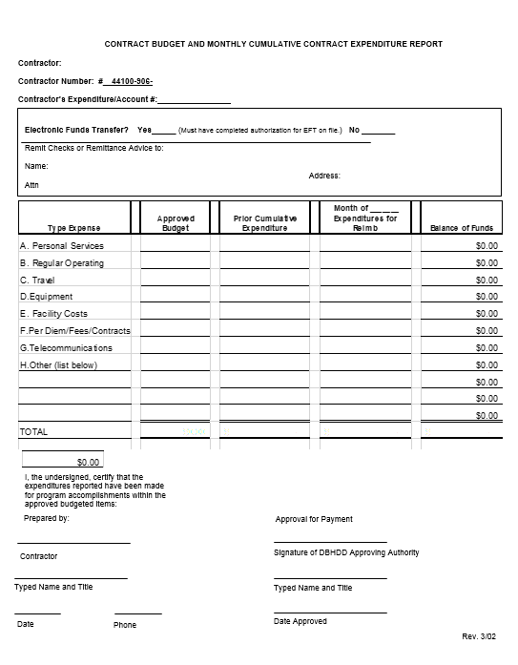

SAMPLE

Monthly Budget Narrative
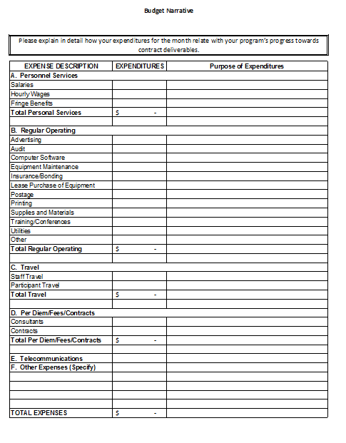

SAMPLE

Monthly Programmatic Report
ASAPP Monthly Progress Report
(Please Type)
Agency Name:
Contract Number:
Contact Person and email address:
Region:
Reporting Period:
Date Submitted:
Number of Attached Documents:

- Participated in Trainings (in the last 30 days)

SAMPLE
Title | Date | List of Attendees | Provided by DBHDD | Provided by (if not DBHDD)
Comments:

- CPAW Meeting(s)
Attach agenda, minutes and sign-in sheets for CPAW
Date | Community | # Attending | Location
Comments on meeting, attendance and stakeholder engagement:

- Coalition Meeting(s)
Attach agenda (minutes and sign-in sheets if available) for Coalition meetings
Date | Community | Purpose of Meeting | # Attending | Location
Comments:

SAMPLE
- Community & Other Stakeholder Meetings
Attach agenda (minutes and sign-in sheets if available) for meetings
Date | Community | Purpose of Meeting | # Attending | Location
Comments:

- Scheduled Meetings for Next Reporting Period
Date | Community | Purpose of Meeting | Location

Attachments:
Meeting Agendas
Meeting sign in sheets
Meeting minutes
Other (Please list below)

SAMPLE

RPS Approval: Yes No Date of Approval (mm/dd/yy): RPS Initials ___________

Strategy 1: _____________________________________________
Please list what action steps or activities, etc., were completed or not completed (and an explanation) based on the proposed plan for Strategy #1 in the past 30 days. (None of these actions or activities should be new or altered.)
Action steps or Activities | Completed, Not Completed or Ongoing | Please explain  SAMPLE

Implementation plan Changes for Strategy # 1
Has the IP changed for this strategy Yes No
Please explain why the IP has changed. (Include new or altered action steps or activities.):

Strategy 2: ____________________________________________
Please list what action steps or activities etc. that were completed or not completed (and an explanation) based on the proposed plan for Strategy #2 in the past 30 days. (None of these actions or activities should be new or altered.)
Action steps or Activities | Completed, Not Completed or Ongoing | Please explain
 |  | SAMPLE

Implementation plan Changes for Strategy # 2
Has the IP changed for this strategy Yes No
Please explain why the IP has changed. (Include new or altered action steps or activities.):

Strategy 3 (If Applicable): ______________________________________________
Please list what action steps or activities, etc., were completed or not completed (and an explanation) based on the proposed plan for Strategy #1 in the past 30 days. (None of these actions or activities should be new or altered.)
Action steps or Activities | Completed, Not Completed or Ongoing | Please explain

SAMPLE
Implementation plan Changes for Strategy # 3
Has the IP changed for this strategy Yes No
Please explain why the IP has changed. (Include new or altered action steps or activities.):

Other
Provide comments or questions related to this past month’s activities:

Implementation Plan

Example Implementation Plans may be found online.
You may access them on the GA-SPS website (see link in “Resources”).

http://ga-sps.org/resources

Budget Adjustment Form
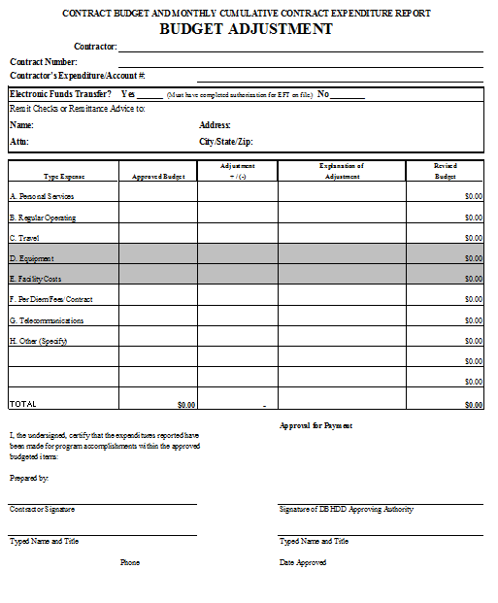

SAMPLE

Creatives Approval Form

Georgia Department of Behavioral Health & Developmental Disabilities
Office of Behavioral Health Prevention
Communications Approval Submission Form

Project Title / Associated Strategy: ____________________________________________

Provider Name: ______________________________________________________________

Provider Contact Name: ______________________________________________________

Provider Contact Information: (email)________________________(ph)______________

Region: 1 2 3 4 5 6

SAMPLE

Type(s) of Material: Poster Brochure Flyer Newspaper article
(check all that apply) Billboard Meme Ad Video
Other _________________

Purpose of the materials (what/how it will be used):

Time frame of use (start/end date):

Target audience:

Date submitted:

Comments:

Technical Assistance

Prospectus Group:
Marcus Bouligny (mbouligny@progroup.us)
Krystal Lokkesmo (krystal@progroup.us)

http://ga-sps.org/

Evaluation

RTI:
Darigg Brown (dcbrown@rti.org)
Elvira Elek (eelek@rti.org)

Resources

All Resources

CADCA (Community Anti-Drug Coalitions of America)
www.cadca.org

SAMHSA (Substance Abuse and Mental Health Services Administration)
www.samhsa.gov
NIDA (National Institute on Drug Abuse)
www.drugabuse.gov

GA-SPS (Georgia Strategic Prevention System)
www.ga-sps.org

GASPS Data Warehouse
www.gaspsdata.net

DBHDD (Department of Behavior Health and Developmental Disabilities)
www.dbhdd.georgia.gov

OBHP (Office of Behavioral Health Prevention)
www.dbhdd.georgia.gov/bh-prevention

NIH (National Institutes of Health)
www.nih.gov

CDC (Centers for Disease Control and Prevention)
www.cdc.gov

