January 2019

Georgia Alcohol and Substance Abuse Prevention Program

Cross-Site Evaluation Manual for Providers

Prepared for

Travis Fretwell, Director

Donna Dent, Assistant Director

Amy Benson, SPF Coordinator

Georgia Department of Behavioral Health &

Developmental Disabilities (DBHDD)

Office of Behavioral Health Prevention

2 Peachtree Street, NW

24th Floor

Atlanta, GA 30303

Prepared by

Elvira Elek, PhD

Darigg Brown, PhD, MPH

Jenna Gabrio, MPH

Ashley Andrews, BA

Laura Baum, MPH

RTI International

3040 E. Cornwallis Road

Research Triangle Park, NC 27709

Contents

Section Page

1 Introduction and Purpose of the Cross-Site Evaluation 1

2 Evaluation Logic Model and Evaluation Questions 2

2.1 Evaluation Logic Model 2

2.2 Evaluation Questions 2

3 Measures and Data Collection 5

3.1 ASAPP Instruments and Measures 5

3.2 Data Collection 8

3.2.1 Process Data Collection 8

3.2.2 Outcomes Data Collection 11

4 Data Analysis 13

4.1 Process Analysis 13

4.2 Outcomes Analysis 16

5 Roles and Responsibilities 17

5.1 Provider Responsibilities 17

5.2 Regional Prevention Specialist Responsibilities 18

5.3 RTI Team Responsibilities 18

Appendices

A Evaluation Questions, Constructs, Instruments, and Items in the Georgia Alcohol and Substance Abuse Prevention Project (GA ASAPP) Evaluation A-1

B Alcohol & Substance Abuse Prevention Project (ASAPP) B-1

C Provider Site Visit Protocols C-1

D Georgia ASAPP Evaluation D-1

E Individual Strategy Survey Request Form E-1

F Georgia Individual Strategy Survey—Middle School Pretest F-1

G Georgia Individual Strategy Survey—High School Pretest G-1

H Georgia Individual Strategy Survey—Parent Pretest H-1

Exhibits

Number Page

1. The ASAPP Evaluation Logic Model 3

2. Data Collection Instruments 6

3. Average Community Readiness Consensus Scores on Community Readiness Scoring Sheet 8

4. Example of Descriptive Analyses Planned for Data From the Ecco Process Evaluation Dashboard 14

5. Roles and Responsibilities of ASAPP Providers, Regional Prevention Specialists, and the RTI Team 17

Acronyms and Abbreviations

|  |  |
| --- | --- |
| ASAPP | Alcohol and Substance Abuse Prevention Program |
| CPAW | community prevention alliance workgroup |
| CSAP | Center for Substance Abuse Prevention |
| DBHDD | Department of Behavioral Health & Developmental Disabilities |
| Ecco | Electronic Coordination Center Operation |
| EOY | End of Year |
| GSHS | Georgia Student Health Survey |
| OBHP | Office of Behavioral Health Prevention |
| RPS | Regional Prevention Specialist |
| RTI International | Research Triangle Institute |
| SAMHSA | Substance Abuse and Mental Health Services Administration |
| SEOW | state epidemiological and outcomes workgroup |
| SPF | Strategic Prevention Framework |
| T/TA | training and technical assistance |
| UAD | underage drinking |

# Introduction and Purpose of the Cross-Site Evaluation

The Alcohol and Substance Abuse Prevention Project (ASAPP) aims to prevent alcohol and substance misuse and abuse and to promote healthy choices and lifestyles among Georgia residents ages 9–25. The six priorities that guide ASAPP serve to strengthen Georgia’s prevention efforts and create measurable results. They are as follows:

1. Reducing access to alcohol among 9- to 20-year-olds

2. Reducing the early onset of alcohol use among 9- to 20-year-olds

3. Reducing binge drinking among 9- to 20-year-olds

4. Reducing binge drinking and heavy drinking among 18- to 25‑year‑olds

5. Reducing the misuse and abuse of community identified high need substances (e.g., marijuana, tobacco, prescription drugs) targeted by individual providers

6. Identify and promote the most effective substance abuse prevention strategies and their key components (Best Practices)

RTI International provides an evaluation framework for the ASAPP that focuses on understanding the relationships between community resources and strategy effectiveness. Our evaluation approach gathers information that providers and state prevention staff need to better address alcohol and substance use in Georgia. The evaluation design uses a mixed-methods approach that integrates multiple sources of qualitative and quantitative data to evaluate the ASAPP.

RTI uses both ***process*** and ***outcome evaluation methods*** to evaluate the effectiveness of the Georgia ASAPP. The *process evaluation* describes programmatic activities (at the state and community levels) associated with the implementation of the ASAPP. This type of evaluation looks at capacity, ensures that prevention efforts reach the targeted groups, and identifies factors that lead to accomplishments or challenges in the implementation of selected strategies. The process evaluation also informs performance improvement during the early stages of implementation at the community level. The *outcome evaluation* looks at the overall effects of the ASAPP, as well as at the effects of selected prevention strategies in terms of intended goals and objectives.

# Evaluation Logic Model and Evaluation Questions

## Evaluation Logic Model

The logic model in ***Exhibit 1*** provides an overview of the ASAPP evaluation. It shows the relationship between ASAPP activities at the state and provider levels and how that relationship influences proximal (immediate) and distal (long-term) outcomes. It also highlights the role of evaluation throughout the process (see Evaluation Components at the bottom of the model).

The logic model includes state-level *inputs* such as funding, Regional Prevention Specialist (RPS) support, and data infrastructure, along with existing community inputs such as community readiness, community stakeholders, and provider capacity and infrastructure. These inputs support *activities* at the state and community levels, including implementation of Strategic Prevention Framework (SPF) steps, training for and technical assistance (T/TA) to providers, formation of community partnerships, and implementation of evidence-based strategies. The *outputs* of these activities will directly lead to increased provider capacity, strengthened prevention infrastructure, increased community knowledge, and policy change, along with improvements in intervening variables such as retail and social access to alcohol, community norms, and perceptions of risk (*proximal outcomes*). The changes in proximal outcomes will produce *long-term (distal) outcomes* on the selected substance abuse priority areas identified in ***Section 1*** (i.e., reducing early onset of alcohol use, underage drinking, binge drinking, and other substance use).

## Evaluation Questions

The RTI ASAPP evaluation team developed the following evaluation questions in collaboration with the Department of Behavioral Health & Developmental Disabilities (DBHDD) Office of Behavioral Health Prevention to determine the degree to which the Georgia ASAPP achieved the ASAPP priorities.

The numbered evaluation questions listed below start with an overarching look at outcomes and then focus on predictors of those outcomes, including the implementation of provider-selected individual and environmental strategies and community and provider characteristics. Lettered process evaluation questions follow each related outcomes evaluation question below.

Exhibit 1. The ASAPP Evaluation Logic Model



ASAPP = Alcohol and Substance Abuse Prevention Program; CPAW = Community Prevention Alliance Workgroup; DBHDD = Department of Behavioral Health & Developmental Disabilities; OBHP = Office of Behavioral Health Prevention; RPS = Regional Prevention Specialist; SPF = Strategic Prevention Framework; TA = technical assistance.

1. Was the implementation of the Alcohol and Substance Abuse Prevention Project (ASAPP) associated with improvements in outcomes (i.e., underage drinking, binge drinking, marijuana use, tobacco use, and prescription drug misuse, along with the intervening variables such as retail and social access to alcohol, community norms, and perceptions of risk)?

a. Which priority areas and demographic groups did the ASAPP providers target?

2. How were specific ASAPP strategies related to outcomes? How were the different types and combinations of ASAPP strategies associated with outcomes?

a. Which strategies did providers most commonly implement?

b. What types of successes and challenges did providers encounter while implementing their selected strategies? Did these successes and challenges differ by the type of strategy or by region?

c. What solutions did providers develop to address the challenges they faced?

d. What types of adaptations did providers make to their implemented strategies?

3. How were the dosage and reach of the implemented ASAPP strategies related to outcomes?

a. How did dosage differ across different types of strategies and providers? (dosage = amount of intervention implemented including number and length of class sessions; number of posters or billboards or ads; number of compliance checks, etc.)

b. How did reach differ across different types of strategies and providers? (reach = number of targeted individuals who experienced the intervention – i.e. attended the classes, saw the billboards, or live in the neighborhood served by the alcohol vendor)

4. How was implementation of the Strategic Prevention Framework (SPF) steps related to outcomes?

a. Which SPF steps did providers implement in their communities?

b. How did the state and providers implement each step?

5. How were (1) community engagement and (2) partnerships with organizations and key stakeholders related to outcomes?

a. Which community groups/organizations and key stakeholders did providers report engaging in their ASAPP efforts?

b. How engaged were the members from those different community groups/organizations and the key stakeholders?

6. How were community readiness, provider capacity, prevention infrastructure, training and technical assistance (T/TA), and other contextual factors associated with strategy implementation and outcomes?

a. What were the initial levels of community readiness, provider capacity, and prevention infrastructure at the start of the ASAPP? How did these factors change over time?

b. What kinds of T/TA did providers request? What kinds of T/TA did providers most often receive?

c. What contextual factors did providers report most often as having affected their strategy implementation? Did the impact of various contextual factors change over time?

Providers can use these evaluation questions as a guide for developing their own questions for their evaluations of their ASAPP prevention efforts.

# Measures and Data Collection

## ASAPP Instruments and Measures

***Exhibit 2*** summarizes the evaluation data collection instruments at the provider (community) level. Each data source contains information that can be used to answer both the evaluation questions listed in ***Section 2.2*** and specific evaluation questions developed by each provider (as they pertain to their local priorities and research interests). More detail about each instrument is in ***Section 3.2***.

The ASAPP logic model and evaluation questions informed the selection and development of all data collection instruments, measures, and related constructs. ***Appendix A*** details the constructs and variables covered by the logic model and evaluation questions, with color coding to match the logic model: blue for inputs, purple for outputs, and green for outcomes. Each construct in the exhibit is linked to specific questions in the data collection instruments; see the specific instruments for exact wording of items and response options. Providers can use the information listed in ***Appendix A*** to help them answer the evaluation questions related to their own ASAPP activities.

Exhibit 2. Data Collection Instruments

|  |  |  |  |  |
| --- | --- | --- | --- | --- |
| Name of Tool(s) | Description of Tool | Target Population | Frequency of Collection | Resources |
| Community Readiness Assessment | Providers interview key stakeholders, partners, and other community members to examine community readiness to implement prevention activities | Community stakeholders | * Beginning of funding * Beginning of Year 3 * End of funding | Community Readiness Handbook from Tri-Ethnic Center: [http://resources. ga-sps.org/resources/community-readiness-handbook](http://resources.ga-sps.org/resources/community-readiness-handbook) |
| Provider Capacity, Infrastructure, and SPF Steps Tool | Providers submit information via the Ecco data collection system overseen by the Prospectus Group. | ASAPP providers | Annually beginning in 2018 | To be determined |
| Implementation Plans, Process Evaluation Dashboard, & Technical Assistance Requests | ASAPP providers submit data into the Ecco data collection system overseen by the Prospectus Group. The Implementation Plans show which ASAPP strategies providers plan to implement. The Process Evaluation Dashboard allows providers to describe their implemented activities. TA requests allow providers to communicate their needs for assistance. | ASAPP providers | Ongoing | See Ecco system information |
| Provider End of Year/Contract Reports | Georgia’s DBHDD-OBHP sends electronic copies of providers’ End of Year reports to the RTI team, which abstracts data on providers’ accomplishments and challenges in the implementation of each of their selected strategies, proposed solutions to the challenges, adaptations to their interventions, and information on partner/stakeholder engagement. | ASAPP providers | Annually | See ***Appendix B*** |

(continued)

Exhibit 2. Data Collection Instruments (continued)

|  |  |  |  |  |
| --- | --- | --- | --- | --- |
| Name of Tool(s) | Description of Tool | Target Population | Frequency of Collection | Resources |
| Provider Site Visits | The RTI team conducts in-person site visits with providers to obtain more in-depth information on their infrastructure, partnerships, implementation accomplishments, ASAPP challenges, and SPF step implementation. | ~12 ASAPP providers per year | Annually | See ***Appendix C*** |
| Georgia Individual Strategy Surveys (pre- & posttest forms) | The survey has three versions: middle-school-age youth, high school age youth and older, and parents (adults). Providers can request either paper or electronic versions of the survey. | Individual-level strategy program participants | Twice per strategy implementation (pre and post) | See ***Appendices F, G,*** and ***H*** |
| Georgia Student Health Survey 2.0 | The survey is collected annually through the Georgia Department of Education using data elements that focus on recent substance use, experiences with alcohol, tobacco, and other drugs education in the past year, age of first use, perceived risks of substance use, and perceived parent and friend norms regarding substance use. The RTI team aggregates data to the county and regional levels for analysis. | Middle school and high school students in Georgia (6th through 12th grades) | Once per year | Survey questions can be found here: [http://www.gadoe.org/Curriculum-Instruction-and-Assessment/Curriculum-and-Instruction/ GSHS-II/Pages/Georgia-Student-Health-Survey-II.aspx](http://www.gadoe.org/Curriculum-Instruction-and-Assessment/Curriculum-and-Instruction/GSHS-II/Pages/Georgia-Student-Health-Survey-II.aspx) |

ASAPP = Alcohol and Substance Abuse Prevention Program; DBHDD = Department of Behavioral Health & Developmental Disabilities; Ecco = Electronic Coordination Center Operation; OBHP = Office of Behavioral Health Prevention; REDCap = Research Electronic Data Capture; SPF = Strategic Prevention Framework.

|  |
| --- |
| **Example:** To examine how community readiness (CR) is associated with strategy implementation and outcomes, use the average CR score results from the CR Assessment scoring sheets as an indicator of level of CR in each community (see **Exhibit 3**). Consider the overall average CR score as well as the scores in each of the following dimensions: Community Efforts, Community Knowledge of the Efforts, Leadership, Community Climate, Community Knowledge About the Issue, & Resources Related to the Issue. |

Exhibit 3. Average Community Readiness Consensus Scores on Community Readiness Scoring Sheet

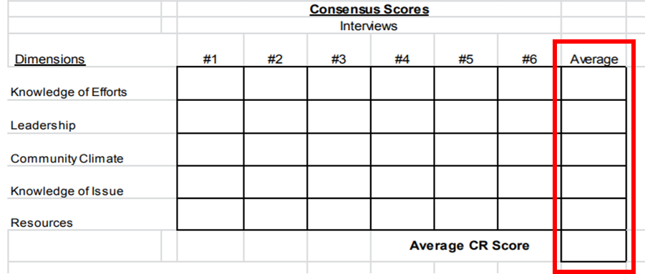

## Data Collection

### Process Data Collection

The process evaluation includes several data collection tools and protocols. Exhibit 2 provides a brief description of those tools, and ***Appendix A*** details information on how the tools and their individual items or sections align with the constructs in the logic model and evaluation questions.

**Community Readiness Assessments:** Providers complete the Community Readiness (CR) Assessment process, including preparing the related scoring sheets, by interviewing key stakeholders, partners, and other community members to examine community readiness to implement prevention activities. The following dimensions have subscales that contribute to the overall CR score: Community Efforts, Community Knowledge of the Efforts, Leadership, Community Climate, Community Knowledge About the Issue, and Resources Related to the Issue. Information on administering and scoring Community Readiness Assessment interviews with community stakeholders can be found in the Community Readiness Handbook from the Tri-Ethnic Center: <http://resources.ga-sps.org/resources/community-readiness-handbook>. The RTI team will obtain electronic copies of the CR Assessment forms from RPSs for each of the providers. RTI will compile both the overall and subscores by provider in an Excel database to use for analysis.

**Provider Capacity, Infrastructure, and SPF Tool:** The RTI team is working with DBHDD-OBHP and Prospectus to develop an online survey in Ecco to assess providers’ ability to carry out activities related to the SPF steps of needs assessment, planning, capacity building, evaluation, and sustainability; their capacity to implement prevention interventions; and their available infrastructure to assess changes over time. Providers will complete the surveys in the Ecco system.

**Implementation Plans, Process Evaluation Dashboard, and TA Requests:** Providers complete Implementation Plans, Process Evaluation Dashboard, and TA requests in the online Ecco system. Implementation Plans show which ASAPP strategies providers plan to implement, including details on target communities and populations. Providers use the Process Evaluation Dashboard to detail all intervention strategies (prevention education, problem identification and referral, environmental, information dissemination, alternative drug-free activities, community-based processes) that their organization implemented during the previous contract year, along with details on numbers served/reached and the amount/dosage of various activities. TA Request Data gives information on the general subject of the request (e.g., evaluation, implementation, technology) as well as specifics of the request (e.g., requests for individual strategy surveys or requests for help on how to enter reach data related to media campaigns).

**End of Year Reports:** Providers complete End of Year (EOY) reports and submit them to DBHDD-OBHP each year (see ***Appendix B*** for the FY2018 template). The DBHDD-OBHP, in turn, provides electronic copies of providers’ EOY Reports to the RTI team, which abstracts information to help providers refine their implementation strategies and help OBHP consider decisions about future strategy selection. Information useful for cross-site evaluations includes the following:

* the provider’s name and four-digit provider code,
* the applicable time period [fiscal year] covered by each report,
* strategy type (individual or environmental),
* each accomplishment related to the implementation of the strategy,
* each challenge related to the implementation of the strategy, and
* actions the provider took to overcome any of the challenges mentioned,
* adaptations to their interventions, and
* information on partner/stakeholder engagement.

RTI will transfer the partner/stakeholder engagement scores providers record in the EOY Reports to an Excel file and code them into relevant stakeholder sectors such as the following:

|  |  |
| --- | --- |
| * Business community * Military * Civic or volunteer organizations * Other state, local, or tribal government agencies * Clergy/faith-based organizations * Other youth-serving organizations * Colleges and universities * Parents/family/caregiver groups * Courts/judiciary system | Schools/school districts  Health care professionals/ agencies  Substance abuse prevention organizations  Law enforcement agencies  Substance abuse treatment organizations  Media (radio/TV stations; newspapers)  Volunteers  Mental health professionals/agencies  Youth groups/representatives |

**Provider Site Visits:** The RTI team conducted individual site visits with a subset of the providers beginning in 2018. Site visits occur in conjunction with the OBHP RPSs and include a presentation by the provider staff, an interview with the ASAPP coordinator, an interview with a CPAW member or other key stakeholder, and an observation of individual strategy implementation. The site visits collect contextual information and allow the RTI team to provide direct evaluation-related TA to providers.

The RTI team developed protocols for the site visits in collaboration with DBHDD-OBHP staff (see ***Appendix C*** for the FY2018 protocols). The provider project coordinator protocols include questions on community characteristics, provider characteristics, and SPF step implementation, including community needs assessments, community/provider capacity (readiness, partnerships), strategic plans, strategy implementation (and adaptations), evaluation, and sustainability. The CPAW/stakeholder protocols include questions on community involvement, CPAW activities, cultural competence, and community characteristics.

### Outcomes Data Collection

To assess the impact of GA ASAPP intervention strategies on the identified GA ASAPP priority areas related to alcohol and substance use, the RTI team analyzes data collected from the Georgia Student Health Survey 2.0 (GSHS 2.0) and the Georgia Individual Strategy Surveys. The GSHS 2.0 data offer community-level outcome measures for providers implementing environmental strategies, whereas the Georgia Individual Strategy Surveys offer outcome measures for providers implementing individual-level ASAPP strategies.

**GSHS 2.0:** The GSHS is an anonymous, statewide annual survey completed by students enrolled in Georgia public school districts (and private schools that wish to participate). RTI analyzes the alcohol- and substance use-related GSHS variables collected from middle school and high school students during the 2015–2016 and later school years, aggregated to the county and regional levels, to assess changes over time. Specific items analyzed by RTI focus on recent substance use (past-30-days); age of first use; perceived risks of substance use; and perceived parent and friend disapproval of the youth’s substance use. RTI compares results in the counties where ASAPP strategies are implemented (ASAPP Counties) to results in counties not implementing ASAPP (non-ASAPP Counties). Providers can access these data through the Georgia Strategic Prevention System (GA SPS) Data Warehouse at <https://www.gaspsdata.net/data/substance>. Providers can view the survey questions at <http://www.gadoe.org/Curriculum-Instruction-and-Assessment/Curriculum-and-Instruction/GSHS-II/Pages/Georgia-Student-Health-Survey-II.aspx>.

**Georgia Individual Strategy Surveys:** Providers implementing individual-level ASAPP strategies will administer Georgia Individual Strategy Surveys to each of their intervention participants both before they start the intervention (pretest) and again after they have completed it (posttest). The RTI team created three different versions of the survey: (1) one for middle-school-aged participants (~10 to 13 years old), (2) one for high-school-aged and young adult participants (~14 years old and up); and (3) one for parents and other adults. Each survey is available in both English and Spanish. The RTI team revised the youth survey used in the Alcohol Prevention Project evaluation to reflect the ASAPP state priorities and provider targeted outcomes. RTI also developed a new parent survey to meet the provider need to gather information from parents in individual programs.

The surveys collect the following information from the high-school-aged and older youth: demographics (gender, ethnicity, race, age, and grade or educational status); past 30-day alcohol, marijuana, prescription drug, and electronic vapor product use; lifetime alcohol and marijuana use; perceived access to alcohol and marijuana; perceived peer use of alcohol; parental and personal norms for youth alcohol and marijuana use; perceived risk of alcohol and marijuana use; parental communication about alcohol use; source of alcohol; and intentions to drink alcohol or smoke marijuana.

The middle school version of the surveys eliminates questions on recent substance use, parental norms, and intentions to use. The parental version of the surveys modifies the questions on access and norms to make them more appropriate for that group (and to reflect their views of youth use).

The RTI team will take lead responsibility for compiling and aggregating Georgia Individual Strategy Survey data submitted by the providers. To help reduce provider burden, RTI developed both an online version (using REDCap) and a hard-copy (paper-and-pencil) version of the surveys for providers to administer to their participants.

Complete instructions for requesting blank surveys for administration and submitting completed surveys for data capture are found in the *Data Collection and Submission Procedures* document in ***Appendix D*** and online online: <http://resources.ga-sps.org>. To request paper or online surveys, providers must complete an *Individual Strategy Survey Request Form* (see ***Appendix E*** and online: <http://resources.ga-sps.org>). Providers should submit their completed form in a new TA request ticket via the Ecco system. Paper survey requests must be submitted to RTI at least 21 business days before the expected survey administration date to allow time for the requested surveys to be printed and shipped to providers.

* **REDCap (Online) Individual Strategy Surveys**: Once RTI receives all necessary information from the provider, RTI will generate a survey link that will contain prepopulated information unique to each provider (e.g., 4-digit provider code [Provider ID]). When a participant completes the online survey and clicks “Submit,” the survey data go directly to RTI’s REDCap system. The RTI team will download the survey data sets quarterly into a single electronic dataset (Excel, SPSS, etc.) to analyze and to share data with providers.
* **Paper (Hard-Copy) Individual Strategy Surveys:** Once RTI receives all necessary information from the provider, RTI will print the number of surveys requested by each provider. Each provider’s Provider ID and an auto-generated ID number unique to each individual survey (Case ID) will also be printed on each survey. The printed surveys will then be shipped to each provider at the mailing address indicated. After administering the surveys, providers will collect, pack, and ship the completed surveys back to RTI for processing (see ***Appendix D*** for detailed instructions on where and how to submit completed surveys). RTI will receipt, scan, and extract the data from each completed survey and then export the data electronically to an Excel file. Providers will receive the data from their scanned paper surveys quarterly. ***Appendices F, G,*** and ***H***, respectively, contain pretest examples of the English-language versions of the middle school, high school, and parent versions of the Georgia Individual Strategy Surveys.

# Data Analysis

## Process Analysis

For all process data sources described in ***Section 3.2.1***, the RTI team will conduct preliminary analyses (e.g., descriptive statistics and frequencies) of all relevant variables in the overall sample. The RTI team will consider strategies separately on the basis of strategy and service type, but we will also compare across strategy and type where possible. Regional differences will also be considered. The RTI team will generate combined summary measures and subscales, where possible, to provide more concise and simplified analysis. The planned descriptive analyses for the Ecco Process Evaluation Dashboard data (***Exhibit 4***) provide an example of how data from one data source will answer multiple evaluation questions.

Exhibit 4. Example of Descriptive Analyses Planned for Data From the Ecco Process Evaluation Dashboard

To address the process evaluation questions, we will summarize descriptive statistics and frequencies by provider, strategy, strategy type, and service type, as relevant for the following constructs

|  |  |  |  |
| --- | --- | --- | --- |
| Evaluation Question | Subtopic | Descriptive Analyses | |
| 1a |  | * Approved state priority areas * Targeted age groups * Targeted population types | * Target audiences * Socioecological targets |
| 3a, 3b | Alternative drug-free activities | * Number of sessions * Average session length | * Session frequency * Total numbers served/reached |
| Community-Based Processes | * Number of stakeholder/partner meetings * Number of stakeholders/ partners, community members, community organizations trained | * Total number of individuals reached/affected |
| Environmental Strategies | * Number of providers imple­menting each strategy by strategy subtype (e.g., training of environmental influencers; policy enactment, establish­ment, or enforcement) | * Number of individuals reached by strategy |
| For Training of Environmental Influencers Activities: | |
| * Whether intervention is recurring * Average number of sessions per group * Frequency of sessions per group | * Average session length * Number of training cycles implemented * Format of training |
| For Enforcement Activities: | |
| * Number of retailer outlets targeted * Number and percentage of retailer outlets at which activity is implemented * Total number of activities conducted | * Number of law enforcement agencies partnered with to conduct activities * Number and frequency of sobriety checkpoints established |

(continued)

Exhibit 4. Example of Descriptive Analyses Planned for Data From the Ecco Process Evaluation Dashboard (continued)

|  |  |  |  |
| --- | --- | --- | --- |
| Evaluation Question | Subtopic | Descriptive Analyses | |
| 3a, 3b | Information Dissemination | * Total number of ads/PSAs aired * Number of weeks a billboard, ad, or PSA ran * Number of stations airing ad or PSA * Number of locations billboards displayed * Number and type of special events, promotional activities, or community meeting presentations conducted * Number of letters sent to newspaper or newsletter editors | * Number of locations/organizations receiving informational materials * Total number of informational materials distributed * Number and percentage of alcohol retail outlets implementing activity * Number and percentage of pharmacies implementing activity * Reach of ads, PSAs, and billboards (rating points; average number of viewers, geographic area, target audience) * Total number of individuals reached |
| Prevention Education | * Number of sessions per group * Frequency of sessions * Average session length | * Number of cycles * Formats of sessions * Total number of individuals served |
| Problem Identification and Referral | * Number of locations implementing strategy | * Total number of individuals for whom problem identification and referral services made available |
| 5 |  | * Settings/locations in which alternative drug-free activities, prevention education, and problem identification and referral are held * Organizations/agencies engaged in environmental strategies * Groups of environmental influencers trained | * Number of law enforcement agencies partnering for activities * Number of community groups or organizations presenting awareness-raising information * Size and composition of community meeting audiences |

PSA = public service announcement.

For qualitative data, such as open-ended descriptions of strategy accomplishments and challenges from the EOY Reports, or information gathered during the site visits, the RTI team will pull out specifically relevant pieces of the collected information and categorize it in a Microsoft Excel spreadsheet.

|  |
| --- |
| **Example of qualitative categorizing:**  For the EOY-reported accomplishments, the RTI team takes each individually listed accomplishment, puts it onto a separate line in the spreadsheet, and then decides which of a list of codes best describes that accomplishment (data collection, engaging key stakeholders, short-term outcome, etc.). These codes help the team label each accomplishment, compile the accomplishments across providers, further organize the accomplishments by category, and summarize the accomplishments by strategy. |

## Outcomes Analysis

To assess the impact of the Georgia ASAPP intervention strategies on the identified priority areas related to alcohol and substance use, the RTI team will analyze data collected from the GSHS 2.0 and the Georgia Individual Strategy Surveys. For both data sources, RTI will first conduct preliminary analyses of all relevant variables in the overall sample (e.g., descriptive statistics and frequencies)—that is, all items from the Georgia Individual Strategy Survey and the demographic and substance use-related variables from the GSHS 2.0. To assess the impact of ASAPP intervention strategies on substance use, we plan the following analyses for each data source.

* **GSHS 2.0:** For the GSHS, RTI will combine the 2015–2016 and later data sets into a single dataset for analysis. RTI will compare changes over time in the counties where ASAPP strategies are implemented (ASAPP Counties) and in counties not implementing ASAPP (non-ASAPP Counties). We will conduct a series of logistic regression and analysis of variance models, which will include variables to account for time (2015–2016 compared with later years), ASAPP condition (ASAPP County compared to non-ASAPP County), and the interaction between the two as covariates or independent variables.
* **Georgia Individual Strategy Surveys:** We will combine all submitted pre- and posttest data into a single dataset and clean the data (assess missing data, check for outliers, etc.) before analysis. Pre- and posttests will be matched by provider (not individually) for analysis. The RTI team will conduct a series of paired t-tests to assess mean change in all survey variables over time.
* **Comparisons With State and National Rates:** RTI will compare longitudinal results from the GSHS 2.0 and the Georgia Individual Strategy Surveys to other state and national substance use prevalence reports, such as those collected by the National Survey on Drug Use and Health and the Monitoring the Future study.

# Roles and Responsibilities

RTI will work collaboratively with ASAPP providers, RPSs, and DBHDD-OBHP leadership to accomplish all data collection and evaluation activities. We incorporated lessons learned from the previous Alcohol Prevention Project evaluation to improve the quality and timeliness of evaluation data, as well as reduce provider data submission burden. ***Exhibit 5*** summarizes the roles and responsibilities of providers, RPSs, and the RTI team. Responsibilities are further described in ***Sections 5.1–5.3***.

Exhibit 5. Roles and Responsibilities of ASAPP Providers, Regional Prevention Specialists, and the RTI Team

|  |  |  |
| --- | --- | --- |
| ASAPP Providers | Regional Prevention Specialists | RTI Team |
| * Submit all individual-level strategy data on time * Request Georgia Individual Strategy Surveys at least 15 days before they are needed * Solicit help by submitting TA requests via Ecco * Participate in site visits and other data collection activities * Maintain effective communication with the RTI team, using RPS or Ecco as a first point of contact | * Ensure that providers submit all data on time and complete necessary evaluation instruments * Forward evaluation-related questions from providers to the RTI team * Participate in data collection activities (e.g., phone interviews) * Arrange for RTI site visits with providers * Participate in TA phone calls and informal “office hours” sessions | * Develop and present evaluation-related trainings and informal “office hours” sessions for providers * Respond to evaluation-related TA requests via Ecco * Conduct data collection activities (e.g., site visits, interviews) with providers * Generate and deliver requested surveys and survey databases to providers * Consolidate and analyze data to generate reports and presentations |

ASAPP, Alcohol and Substance Abuse Prevention Project; TA, technical assistance.

## *Provider Responsibilities*

To facilitate evaluation activities, we expect all ASAPP providers to submit data on time. A provider who anticipates a delay in submitting data should notify its RPS, and the RPS will in turn notify the RTI team. A provider also may request TA through the Ecco system to get help with solutions to make sure that data submissions occur on time.

We expect providers to submit data through all of the ASAPP evaluation instruments. These include the Implementation Plan; Georgia Individual Strategy pre- and posttest surveys (online or paper format); and other instruments, including assessments of community readiness, prevention infrastructure, and organizational capacity.

Providers should notify the RTI team immediately if they need additional Georgia Individual Strategy Surveys. Providers should not make photocopies of the survey for data collection, as these photocopies cannot be scanned to include in the database.

Last, providers will be expected to maintain effective communication with the RTI team. This includes sending questions through their RPSs, submitting TA requests through the Ecco system, participating in site visits and other in-person meetings as scheduled, participating in individual TA telephone calls, and participating (as needed) in regular “office hours” informal chats with other providers.

## *Regional Prevention Specialist Responsibilities*

The RPS responsibilities for the evaluation are framed around the provider responsibilities outlined in ***Section 5.1***. RPSs should make sure that providers submit data on time and complete all necessary evaluation instruments. RPSs will forward any evaluation-related questions they receive from providers to the RTI team in a timely manner. RPSs will participate in data collection activities directed specifically at them (e.g., telephone interviews with OBHP staff). They will also work with RTI and the providers to arrange for RTI site visits each spring. Last, RPSs should participate in individual TA phone calls and informal “office hours” chats to hear providers’ concerns and to get a better sense of the progress of implementation and evaluation activities and any related challenges.

## *RTI Team Responsibilities*

The RTI team will develop and hold evaluation-related trainings as webinars or as in-person presentations at DBHDD-OBHP conferences or other settings. We will also hold regular informal “office hours” chats for providers to discuss evaluation-related questions or concerns. The RTI team will track evaluation-related TA requests in Ecco and respond to providers promptly. We will work with providers to find solutions to ensure that data submissions occur on time.

The RTI team will coordinate and participate in all relevant data collection activities, including working with RPSs to arrange provider site visits.

In response to Georgia Individual Strategy Survey requests, the RTI team will oversee the process of proofing, printing, and shipping the requested surveys with the aim of delivering surveys to providers within three weeks of the request (or, alternatively, providing relevant REDCap information to the provider within 1 week). Once providers return paper versions of the surveys, the RTI team will oversee the process of scanning the surveys for data entry and developing related databases. The RTI team will provide Georgia Individual Strategy Survey data sets to providers quarterly for all data submitted in that quarter.

The RTI team will consolidate all evaluation-relevant data; process the data as needed; and analyze the data for annual evaluation reports, other reports, and presentations as requested by DBHDD-OBHP. The RTI team will share the findings with providers, RPSs, and other stakeholders as requested by DBHDD-OBHP.

Appendix A  
Evaluation Questions, Constructs, Instruments, and Items in the Georgia Alcohol and Substance Abuse Prevention Project (GA ASAPP) Evaluation

| **Construct** | **Data Source** | | **Instrument Items and Item Description** |
| --- | --- | --- | --- |
| **EQ1. 1. Was the implementation of ASAPP associated with improvements in outcomes (i.e., underage drinking, binge drinking, marijuana use, tobacco use, and prescription drug misuse, along with the intervening variables such as retail and social access to alcohol, community norms, and perceptions of risk)?**   * 1. **Which priority areas and demographic groups do ASAPP providers target?** | | | |
| Early onset of use (age first used) | Georgia Individual Strategy Survey – Middle and High School+ Versions | | Middle School: Q6 (alcohol), Q7  (e-cigarette), Q8 (marijuana)  High School+: Q7 (alcohol), Q8 (marijuana) |
|  | GSHS 2.0 2015/2016 | | Q94 (alcohol), Q95 (cigarette),  Q97 (marijuana), Q100 (prescription drugs w/o prescription) |
| Substance use (days using in past 30) | Georgia Individual Strategy Survey – Middle and High School+ Versions | | Middle School: Q16 (alcohol)  High School+: Q6 (alcohol, marijuana, prescription drugs, e-cigarette) |
|  | GSHS 2.0 2015/2016 | | Q50 (alcohol), Q51 (cigarettes), Q53  (e-vapor products), Q54 (marijuana),  Q58 (prescription drug painkiller w/o prescription), Q59 (prescription drug tranquilizer/sedative w/o prescription),  Q60 (prescription drug stimulant w/o prescription) |
| Binge drinking (days in past 30) | Georgia Individual Strategy Survey – High School+ Version | | Q6 |
|  | GSHS 2.0 2015/2016 | | Q55 |
| Retail and social access to alcohol | Georgia Individual Strategy Survey – Parent, Middle, and High School+ Versions | | Parent: Q7 (easy to get), Q8, Q9 (home monitoring), Q13 (acceptable provide alcohol), Q16, Q17 (others approve providing alcohol)  Middle School: Q9 (easy to get), Q16 (how usually get)  High School: Q9 (easy to get), Q18 (how usually get) |
| Access to marijuana | Georgia Individual Strategy Survey – Parent, Middle, and High School+ Versions | | Parent: Q10 (easy for parent to get),  Q18 (easy four youth to get)  Middle School: Q10 (easy to get)  High School: Q10 (easy to get) |
| Community/Individual norms | Georgia Individual Strategy Survey – Parent, Middle, and High School+ Versions | | Parents: Q16, Q17 (community adult norms alcohol), Q11 (parent norms alcohol),  Q19 (parent norms marijuana)  Middle School: Q11 (peer use alcohol),  Q12 (personal norm alcohol),  Q13 (personal norm marijuana)  High School: Q11, Q12 (peer use alcohol), Q13 (perception of adult norms alcohol, marijuana), Q14 (personal norm alcohol), Q15 (personal norm marijuana) |
|  | GSHS 2.0 2015/2016 | | Q106 (parent alcohol), Q107 (parent tobacco), Q108 (parent marijuana), Q109 (parent prescription drug), Q110 (friend alcohol), Q111 (friend tobacco), Q112 (friend marijuana), Q113 (friend prescription drug) |
| Perceptions of risk | Georgia Individual Strategy Survey – Parent, Middle, and High School+ Versions | | Parents: Q14 (regular drinking), Q15 (binge drinking), Q20 (marijuana)  Middle School: Q14 (binge drinking); Q15 (marijuana)  High School: Q14 (regular drinking), Q16 (binge drinking), Q17 (marijuana) |
|  | GSHS 2.0 2015/2016 | | Q101 (binge drinking), Q102 (regular drinking), Q103 (smoking cigarettes), Q104 (marijuana), Q105 (prescription drugs w/o prescription) |
| Other outcomes | Georgia Individual Strategy Survey – Parent, Middle, and High School+ Versions | | Parent: Q12 (parent communication re. alcohol), Q21 (parent communication re. marijuana), Q22 (parent use of alcohol, binge drinking, marijuana, and prescription drugs)  Middle School: Q17 (parent communication alcohol), Q18 (intentions to use alcohol, marijuana)  High School: Q19 (parent communication alcohol), Q20 (intentions to use alcohol, binge drink, smoke marijuana) |
|  | GSHS 2.0 2015/2016 | | Q71 (occasions driven car while drinking in past 30 days), Q72 (occasions rode in car w/someone drinking in past 30 days) |
| Priority areas | ASAPP Provider Database | | Primary, secondary, and tertiary priority areas |
| Demographics | Ecco Strategy Implementation Plan | | Section D.4 – age groups and population types targeted; socioecological targets |
| **EQ2: How are specific ASAPP strategies related to outcomes? How are the different types and combinations of ASAPP strategies associated with outcomes?**   1. **Which strategies did providers most commonly implement?** 2. **What types of accomplishments and challenges did providers encounter while implementing their selected strategies?** 3. **Did the types of strategy implementation accomplishments and challenges providers encountered differ by the type of strategy or by region?** 4. **What solutions did providers develop to address the challenges they faced?** 5. **What types of adaptations did providers make to their implemented strategies?** | | | |
| Strategy type (and # implemented) | Ecco Process Evaluation Dashboard - All | | Header – Intervention Name, Intervention Type, Service Type  Q1 active during reporting period |
| Policies added/changed | Ecco Process Evaluation Dashboard – Environmental - Policy Enactment | | Q11 new policies enacted, established, or implemented |
| Strategy accomplishments, challenges, and solutions | End of Year Reports | | Environmental and Individual Strategy successes/accomplishments, challenges/ barriers, & solutions |
| OBHP Interviews | | Provider implementation challenges and accomplishments |
| Strategy adaptations | EOY Reports | | Approved Strategies Reporting: Describe adaptations or changes |
| Provider Site Visits | | Provider protocol: IV. Strategy implementation – probes on adaptations |
| **EQ3. How was the dosage and reach of the implemented ASAPP strategies related to outcomes?**   1. **How did dosage differ across different types of strategies and providers?** 2. **How did reach differ across different types of strategies and providers?** | | | |
| Dosage | Ecco Process Evaluation Dashboard – Alternative Drug-free Activities | | Q7 number of new groups started  Q8 number of sessions  Q9 average session length  Q11 hours of direct service  Q12 hours of indirect service |
|  | Ecco Process Evaluation Dashboard – Community-based Processes | | Q2 number of stakeholder/partner meetings held  Q3 number of new stakeholder/partner organizations trained  Q5 number of new individuals from stakeholder/partner organizations trained  Q7 number of new community members, other than stakeholders/partners trained  Q9-12 Participant demographics (gender, age, race)  Q13 number of community organizations provided with training or technical assistance  Q14 developing prevention provider network  Q15 reorganizing local agencies to promote efficiency in delivering substance abuse prevention  Q16 reallocating local funds for substance abuse prevention  Q17 formally changing ways local organizations work together to address substance abuse prevention  Q18 conducting other community-based process activities |
|  | Ecco Process Evaluation Dashboard – Environmental | | Q2a-b hours of direct and indirect service |
|  | Ecco Process Evaluation Dashboard – Environmental -Policy Enactment | | Q3-4 number and type of organizations engaged  Q5-6 number of new MOUs established and organization type  Q7 number of presentations delivered |
|  | Ecco Process Evaluation Dashboard – Environmental -Training of Environmental Influencers | | Q12 number of new training groups  Q13 format of training (group size)  Q15 number of training sessions conducted  Q16 average training session length |
|  | Ecco Process Evaluation Dashboard – Environmental -Enforcement Efforts | | Q21a-b number and zip codes of compliance checks conducted  Q21c number of law enforcement agencies engaged in compliance checks  Q22 number establishing sobriety checkpoints  Q23 number collaborating with law enforcement |
|  | Ecco Process Evaluation Dashboard – Environmental -Social Norms Campaign | | Q28 number of locations implementing social norms campaign |
|  | Ecco Process Evaluation Dashboard – Environmental -Prescription Drop Boxes and Medicine Safes | | Q54a-b number and location of drop boxes  Q56 number of drug lock boxes or medicine safes distributed  Q57 number of drug “take back” events participated in |
|  | Ecco Process Evaluation Dashboard – Environmental -Other Environmental Interventions | | Q59 number and type of other environmental interventions |
|  | Ecco Process Evaluation Dashboard – Environmental -Information Dissemination for Environmental Strategies | | 60-82b similar constructs used for information dissemination format types |
|  | Ecco Process Evaluation Dashboard – Information Dissemination | | Q3a hours of direct service  Q4 hours of indirect service  Q5-6 number and type of health promotion events  Q10a-c radio PSAs – number of new ads created; number of ads aired; number of times TV ads air; number of TV stations airing ad  Q11a-c television PSAs – number of new ads created; number of ads aired; number of times radio ads air; number of radio stations airing ad  Q12a-c print ads – number of ads created; number published; number of times ran; number of publications running  Q13a-c posters – number of posters created; number distributed; number displayed; number of locations displaying  Q14a-b brochures – number created; number distributed; number of locations receiving  Q15a-b letters to editor – number sent; number published; number of publications to which letters were sent  Q16a-c billboards – number created; number displayed; number of weeks displayed; number of locations displayed  Q17a-c banners – number created; number displayed; number of weeks displayed; number of locations  Q18a-b presentation materials – number and type of unique materials created; number disseminated  Q19a-c presentations – number delivered; topics; target audience; number of locations  Q21a social media – number and type of unique posts; average amount of time spent on website  Q22a press release – number created; number published  Q23 clearinghouse/information resource center – number  Q24a information/hot/help lines – number  Q25a-b training materials – number and type created; target audience  Q27a-b other – number and type created; number disseminated |
|  | Ecco Process Evaluation Dashboard – Prevention Education | | Q5 number of new groups started  Q6 number of sessions implemented  Q8 average session length  Q9 hours of direct service  Q10 hours of indirect service |
|  | Ecco Process Evaluation Dashboard – Problem Identification and Referral | | Q3-4 number and type of locations implementing  Q6 hours of direct service  Q7 hours of indirect service |
| Reach and Number Served | Ecco Process Evaluation Dashboard – Alternative Drug-Free Activities | | Q13 number of new participants started  Q15-18 participant demographics (gender, age, race)  Q20 number of new participants completed |
|  | Ecco Process Evaluation Dashboard – Community-Based Processes | | Q19 number of individuals reached or affected  Q21-24 demographics of individuals reached (gender, age, race) |
|  | Ecco Process Evaluation Dashboard – Environmental - Policy Enactment | | Q7c, Q8a-e type, demographics, and number of presentation audience members  Q9 number of elected officials contacted |
|  | Ecco Process Evaluation Dashboard – Environmental - Training of Environmental Influencers | | Q17a-l number, training type, and demographics of attendees trained  Q19 number of new individuals completed |
|  | Ecco Process Evaluation Dashboard – Environmental - Social Norms Campaign | | Q29-30 reach of social norms campaign |
|  | Ecco Process Evaluation Dashboard – Environmental - Prescription Drop Boxes and Medicine Safes | | Q55a reach of drop box program  Q58a-b number of participants (people dropping off medications) |
|  | Ecco Process Evaluation Dashboard – Environmental - Information Dissemination for Environmental Strategies | | Q60-82b similar constructs used for information dissemination format types |
|  | Ecco Process Evaluation Dashboard – Information Dissemination | | Q10e-f radio ads – ratings points; average number of viewers at the time the ads aired; target audience of the related programs  Q11e-f Television ads – ratings points; average number of viewers at the time the ads aired; target audience of the related programs  Q12e-f print ads – average readership; target audience  Q13d-e reach of posters  Q15c letters to editor – average readership; target audience of publication  Q16d-e reach of billboards  Q17d-e reach of banners  Q19d-i presentation – number and demographics of attendees  Q20a-d, Q21b-e social media – number of visits to website; number of new visitors; number of unique page views; number of new followers  Q22b press release – average readership; target audience for publication  Q23a-d number of visits to resource center; number of new visitors  Q24a – number of hotline calls received |
|  | Ecco Process Evaluation Dashboard – Prevention Education | | Q12 number of new participants started  Q14-17 participant demographics (gender, age, race)  Q19 number of new participants completed |
|  | Ecco Process Evaluation Dashboard– Problem Identification and Referral | | Q10 number of individuals for whom problem identification and referral services were provided  Q12-15 demographics of individuals receiving service (gender, age, race) |
| **EQ4. How is implementation of the SPF steps related to outcomes?**   1. **Which SPF steps did providers implement in their communities?** 2. **How did the state and providers implement each SPF step?** | | | |
| Implementation of SPF steps | OBHP Interviews and Documents | |  |
|  | Provider Site Visits | | Provider protocol: II. SPF Framework Implementation, III. Capacity and Capacity Building, IV. Strategy Implementation,  V. Evaluation, VI. Sustainability  Stakeholder protocol: CPAW – T/TA received |
|  | Provider Capacity, Infrastructure, and SPF Steps Tool | | TBD |
| **EQ5. How are community engagement and partnerships with organizations and key stakeholders related to outcomes?**   1. **Which community groups/organizations and key stakeholders did providers report engaging in their ASAPP efforts?** 2. **How engaged were the members from those different community groups/organizations and key stakeholders?** | | | |
| Number of stakeholders;  Level of stakeholder engagement | EOY Report | | CPAW, Community Partners, & Key Stakeholders contributions and level of engagement |
| Provider Site Visit | | Provider Protocol: III. Capacity and Capacity building (including stakeholder engagement, CPAW)  Stakeholder Protocol: All |
| **EQ6. How were community readiness, provider capacity, prevention infrastructure, T/TA, and other contextual factors associated with strategy implementation and outcomes?**   1. **What was the initial level of community readiness, provider capacity, and prevention infrastructure at the start of the ASAPP? How did these factors change over time?** 2. **What kinds of T/TA did providers request or indicate they needed? What kinds of T/TA did providers most often receive?** 3. **What contextual factors did providers report most often as having impacted their strategy implementation? Did the most impactful contextual factors change over time?** | | | |
| Community readiness | | Community Readiness Assessment | Overall and subscores on community knowledge of efforts, prevention leadership, community climate, knowledge of their priority area and resources for prevention efforts. |
|  | | Provider Site Visits | Provider Protocol: II. SPF Implementation (community needs and resource assessment, Community Readiness Assessment) |
| Provider capacity | | Provider Site Visits | Provider Protocol: III. Capacity and Capacity Building |
|  | | Provider Capacity, Infrastructure, and SPF Steps Tool | TBD |
| Prevention infrastructure | | OBHP Interviews | I b & c – background, provider, and community characteristics |
|  | | Provider Site Visits | Provider Protocol: II. SPF Implementation, III. Capacity and Capacity Building,  V. Evaluation |
|  | | Provider Capacity, Infrastructure, and SPF Steps Tool | TBD |
| T/TA | | Ecco System | Number of requests; topics |
|  | | OBHP Training summaries | Training topics, # of attendees |
|  | | OBHP Training feedback | Feedback ratings |
|  | | OBHP Interviews | IV – T/TA |
|  | | Provider Site Visits | Provider Protocol III. Capacity and Capacity Building, V. Evaluation  Stakeholder Protocol: CPAW (ASAPP or SPF-related T/TA) |
| Contextual factors | | OBHP Interviews | I b & c – Background, provider, and community characteristics |
|  | | Provider Site Visits | Provider Protocol: I. Community and Provider Characteristics, VII. Wrap-up  Stakeholder Protocol: Cultural competence, Community characteristics |
|  | | Provider Capacity, Infrastructure, and SPF Steps Tool | TBD |

ASAPP = Alcohol and Substance Abuse Prevention Program; CPAW = Community Prevention Alliance Workgroup; Ecco = Electronic Coordination Center Operation; EOY = End of Year; MOU = memorandum of understanding; GSHS = Georgia Student Health Survey; PSA = public service announcement; SPF = Strategic Prevention Framework; TBD = to be determined; T/TA = training and technical assistance.

Appendix B  
Alcohol & Substance Abuse Prevention Project (ASAPP)

**End of the Year Final Report**

**Instructions:**

The Alcohol & Substance Abuse Prevention Project (ASAPP) End of the Year Final Report is due on the last day of each contract year. It is designed to allow you the opportunity to summarize your overall ASAPP project, report on your activities, collaborations/partnerships, accomplishments, challenges and outcomes for the contract year.

Use the attached forms to complete your report and attach necessary Appendices. Please provide accurate, specific, concise and thoughtful responses to all the report sections. Include qualitative and quantitative data in your responses.

This report should provide an overview of the work you have done over the past year to implement each approved strategy in your community(ies).

Address each section of the form with the key/crucial components regarding your communities, your implementation strategies, and all associated activities for FY 2018. The complete report should be submitted to your RPS no later than **Sept 28, 2018**.

The End of Year Report Sections:

Instructions

Page 1 - Introduction

Staff & Partners

Page 2 - Overview

Goals/Community/Strategy Reporting Forms

Page 3 - Strategies (Activities/Fidelity/Accomplishments/Challenges)

Fidelity/Adaptations

Tobacco Prevention Strategy

Project Successes & Challenges - A Lessons Learned

Appendix A – Approved Goals, Communities, & Strategies

Appendix B - IP EOY Report for your Communities (D,

Appendix C – Logic Model for your Community

Appendix D – List of Strategy 1 Activities/Target Pop/Settings/# Served

**Introduction**

|  |  |
| --- | --- |
| **Contractor Organization Name:** | **Region #** |
|  |  |

|  |  |
| --- | --- |
| **Project Coordinator Name:** |  |
| **PC Phone/email:** |  |

|  |  |  |
| --- | --- | --- |
| **Other Staff Title/Role** | **%Effort** | **Start/End Dates** |
|  |  |  |
|  |  |  |
|  |  |  |
|  |  |  |
|  |  |  |

**BACKGROUND** (Start here on Page 1 – Finish on bottom of Page 2, Maximum length: 1 ½ Pages)

|  |
| --- |
| **Provide a Brief Historical to Current Narrative Description of your Community(ies) - prior to the start of your ASAP Project this year**  (i.e. *was there an APP/SIGP or other State Prevention Project prior? Describe the population? Has is grown or shrunk over that past few years? What is the Racial/Ethnic Make-up? Economic/Employment Status, Edu/Avg Grade level, Past to Current Substance Abuse Issues? How do these numbers compare to the state (GA) and the nation (US), what is the landscape (urban, rural, suburban, mountains, coastal, etc.), substance abuse trends, what are the graduation/higher edu rate? What are the death rates? Suicide rates? Hospitalization for Alcohol and/or substance misuse in your community? Overdose rates? Alcohol or Drug related arrest rates? School Drop-out rates? Is this a College/University Town? Is it a Tourist Destination Town? Are there military basis? Etc.*) |

**Overview**

**Compare to Approval Letters - Goals, Communities, & Strategies (Appendix A)**

|  |  |  |
| --- | --- | --- |
| **Describe Changes to Your Approved Goals** | **Date Changed** | **Justification/Reason for Change** |
| **1.** |  |  |
| **2.** |  |  |
| **3.** |  |  |
| **4.** |  |  |
| **Describe Changes to your Approved Communities** | **Date Changed** | **Justification/Reason for Change** |
| **1.** |  |  |
| **2.** |  |  |
| **3.** |  |  |
| **4.** |  |  |
| **Describe Changes to Your Approved Strategies** | **Date Changed** | **Justification/Reason for Change** |
| **1.** |  |  |
| **2.** |  |  |
| **3.** |  |  |
| **4.** |  |  |
| **Describe Changes to your Approved Strategies** | **Date Changed** | **Justification/Reason for Change** |
| **1.** |  |  |
| **2.** |  |  |
| **3.** |  |  |
| **4.** |  |  |

**Strategies**

**Compare to Approved Community Logic Models (Appendix B)**

|  |  |
| --- | --- |
| **Environmental Strategy #1:** |  |
| **Environmental Strategy #1:** |  |

|  |  |
| --- | --- |
| **Individual Strategy #1:** |  |
| **Individual Strategy #2:** |  |

|  |  |  |
| --- | --- | --- |
| **Describe Changes in Strategies** | **Date Changed** | **Justification/Reason for Change** |
| **1.** |  |  |
| **2.** |  |  |
| **3.** |  |  |
| **4.** |  |  |
| **Describe Changes to your Risk/Protective Factors (IV/CF)** | **Date Changed** | **Justification/Reason for Change** |
| **1.** |  |  |
| **2.** |  |  |
| **3.** |  |  |
| **4.** |  |  |
| **Describe Changes in Outcomes** | **Date Changed** | **Justification/Reason for Change** |
| **1.** |  |  |
| **2.** |  |  |
| **3.** |  |  |
| **4.** |  |  |

|  |  |
| --- | --- |
| **Environmental Strategy #1:** |  |

**ACCOMPLISHMENTS**

Include Process Accomplishments – things you were able to do/get done

Include Outcome Accomplishments – what changed (in communities and/or with individuals)?

***Example:***

|  |  |  |  |
| --- | --- | --- | --- |
| **Accomplishment #A** | | | |
| **Process:** *We hosted 5 Town Meetings to raise awareness in Candy County about the benefits of having a Social Host Ordinance (to increase readiness for SHO).*  **Outcome:** *Meeting Pre/Post surveys indicated attendees’ knowledge increased by 60% and attitude towards SHO changed to more positive by 20%. Sign-in sheets listed 460 attendees.* | | | |
| **Estimated Reach** | **Actual # Reached** | **Dosage** | **Frequency** |
| *500 different individuals* | *460 individuals* | *5 Meetings, each 1.5 Hours in length* | *We hosted a New Meeting at a different location in Candy County Every 2 Months* |

|  |  |  |  |
| --- | --- | --- | --- |
| **Accomplishment #1:** | | | |
|  | | | |
| **Estimated Reach** | **Actual # Reached** | **Dosage** | **Frequency** |
|  |  |  |  |
| **Accomplishment #2** | | | |
|  | | | |
| **Estimated Reach** | **Actual # Reached** | **Dosage** | **Frequency** |
|  |  |  |  |
| **Accomplishment #3** | | | |
|  | | | |
| **Estimated Reach** | **Actual # Reached** | **Dosage** | **Frequency** |
|  |  |  |  |
|  | | | |

*(Copy/Paste Rows to Add More Accomplishments if Needed)*

|  |
| --- |
| **Briefly describe how Strategy #1 will be sustained once the project is completed? (**Max length: ½ Page**)** |
|  |

**CHALLENGES/BARRIERS**

Briefly describe all challenges encountered throughout this contract year and solutions found. If you were unable to overcome certain challenges, state so and offer rationale for why not?

|  |
| --- |
| **Challenge #1** |
|  |
| **Solution to Challenge #1** |
|  |

|  |
| --- |
| **Challenge #2** |
|  |
| **Solution to Challenge #2** |
|  |
| **Challenge #3** |
|  |
| **Solution to Challenge #3** |
|  |

*(Copy/Paste Rows to Add More Accomplishments if Needed)*

|  |  |
| --- | --- |
| **Environmental Strategy #2:** |  |

**ACCOMPLISHMENTS**

Include Process Accomplishments – things you were able to do/get done

Include Outcome Accomplishments – what changed (in communities and/or with individuals)?

|  |  |  |  |
| --- | --- | --- | --- |
| **Accomplishment #1:** | | | |
|  | | | |
| **Estimated Reach** | **Actual # Reached** | **Dosage** | **Frequency** |
|  |  |  |  |
| **Accomplishment #2** | | | |
|  | | | |
| **Estimated Reach** | **Actual # Reached** | **Dosage** | **Frequency** |
|  |  |  |  |
| **Accomplishment #3** | | | |
|  | | | |
| **Estimated Reach** | **Actual # Reached** | **Dosage** | **Frequency** |
|  |  |  |  |

*(Copy/Paste Rows to Add More Accomplishments if Needed)*

|  |
| --- |
| **Briefly describe how Strategy #1 will be sustained once the project is completed? (**Max length: ½ Page**)** |
|  |

**CHALLENGES/BARRIERS**

Briefly describe all challenges encountered throughout this contract year and solutions found. If you were unable to overcome certain challenges, state so and offer rationale for why not?

|  |
| --- |
| **Challenge #1** |
|  |
| **Solution to Challenge #1** |
|  |
| **Challenge #2** |
|  |
| **Solution to Challenge #2** |
|  |
| **Challenge #3** |
|  |
| **Solution to Challenge #3** |
|  |

*(Copy/Paste Rows to Add More Accomplishments if Needed)*

|  |  |
| --- | --- |
| **Individual Strategy #1:** |  |

**ACCOMPLISHMENTS**

Include Process Accomplishments – things you were able to do/get done

Include Outcome Accomplishments – what changed (in communities and/or with individuals)?

|  |  |  |  |
| --- | --- | --- | --- |
| **Accomplishment #1:** | | | |
|  | | | |
| **Estimated Reach** | **Actual # Reached** | **Dosage** | **Frequency** |
|  |  |  |  |
| **Accomplishment #2** | | | |
|  | | | |
| **Estimated Reach** | **Actual # Reached** | **Dosage** | **Frequency** |
|  |  |  |  |
| **Accomplishment #3** | | | |
|  | | | |
| **Estimated Reach** | **Actual # Reached** | **Dosage** | **Frequency** |
|  |  |  |  |
|  | | | |

*(Copy/Paste Rows to Add More Accomplishments if Needed)*

|  |
| --- |
| **Briefly describe how Strategy #1 will be sustained once the project is completed? (**Max length: ½ Page**)** |
|  |

**CHALLENGES/BARRIERS**

Briefly describe all challenges encountered throughout this contract year and solutions found. If you were unable to overcome certain challenges, state so and offer rationale for why not?

|  |
| --- |
| **Challenge #1** |
|  |
| **Solution to Challenge #1** |
|  |
| **Challenge #2** |
|  |
| **Solution to Challenge #2** |
|  |
| **Challenge #3** |
|  |
| **Solution to Challenge #3** |
|  |

*(Copy/Paste Rows to Add More Accomplishments if Needed)*

|  |  |
| --- | --- |
| **Individual Strategy #2:** |  |

**ACCOMPLISHMENTS**

Include Process Accomplishments – things you were able to do/get done

Include Outcome Accomplishments – what changed (in communities and/or with individuals)?

|  |  |  |  |
| --- | --- | --- | --- |
| **Accomplishment #1:** | | | |
|  | | | |
| **Estimated Reach** | **Actual # Reached** | **Dosage** | **Frequency** |
|  |  |  |  |
| **Accomplishment #2** | | | |
|  | | | |
| **Estimated Reach** | **Actual # Reached** | **Dosage** | **Frequency** |
|  |  |  |  |
| **Accomplishment #3** | | | |
|  | | | |
| **Estimated Reach** | **Actual # Reached** | **Dosage** | **Frequency** |
|  |  |  |  |
|  | | | |

*(Copy/Paste Rows to Add More Accomplishments if Needed)*

|  |
| --- |
| **Briefly describe how Strategy #1 will be sustained once the project is completed? (**Max length: ½ Page**)** |
|  |

**CHALLENGES/BARRIERS**

Briefly describe all challenges encountered throughout this contract year and solutions found. If you were unable to overcome certain challenges, state so and offer rationale for why not?

|  |
| --- |
| **Challenge #1** |
|  |
| **Solution to Challenge #1** |
|  |
| **Challenge #2** |
|  |
| **Solution to Challenge #2** |
|  |
| **Challenge #3** |
|  |
| **Solution to Challenge #3** |
|  |

*(Copy/Paste Rows to Add More Accomplishments if Needed)*

**CPAW, COMMUNITY PARTNERS AND KEY STAKEHOLDERS**

|  |
| --- |
| **Background:**  *Discuss Recruitment, how your CPAW functioned, accomplishments, challenges, and how it evolved over the contract cycle. Discuss number of members? Number of Meetings? Engagement of members? Formal vs Informal Commitments? Who were your biggest supporters, Champions (how/what motivated them) and what were your biggest hurdles? Who wasn’t involved that you thought would be?* |
|  |

**List types of key stakeholders and CPAW Members and the Contributions they made towards your strategies**

*\*[****Rate Level of Engagement****:* ***0=None****, In Name only;* ***1=Slightly*** *Engaged, Attended > have mtgs and offered very little input;* ***2=Somewhat*** *Engaged, Attended > half of the mtgs but offered some input at each;* ***3=Fairly*** *Engaged, Attended < half of mtgs and offered much input;* ***4=Fully*** *Engage, Attended < half mtgs and offered input every time.]*

|  |  |  |  |
| --- | --- | --- | --- |
| **Sectors Repre-sented**  **(Agency Type/ Commu-nity)** | **Level of En-gage-ment\*** | **Title/ Position** | **Contributions to Your CPAW/Strategies**  [Use Contribution(s) Key below]** |
| Example:  Sheriff’s Office | 4 | Deputy Sheriff | (B,E) Advisory Committee Member. Shared alcohol related arrest data, Participated on panel discussions and gave presentations at community meetings. |
|  |  |  |  |
|  |  |  |  |
|  |  |  |  |
|  |  |  |  |
|  |  |  |  |
|  |  |  |  |
|  |  |  |  |
|  |  |  |  |
|  |  |  |  |
|  |  |  |  |

**\*\*Key for Types of Contributions to Your CPAW/Strategies**

**A** They identified/made available additional data resources

**B** They identified/gave access to the population we served

**C** They provided additional manpower/workforce

**D** They provided new perspectives (nontraditional partners) within our community

**E** They assisted with community buy-in (trust/credibility)

**F** They advised/gave input to the process based on their experience

**G** They provided additional funding and/or material resources

**H** They provided political clout/insight/authority

**I** Other (describe):

**COALITION RELATIONSHIP**

|  |
| --- |
| **Discuss Participation with Coalitions:**  What coalitions have you joined and/or collaborated with to implement ASAPP. Are other members of the coalition involved in your project? What have your success and challenges with this coalition been related to ASAPP? |
|  |

**TOBACCO PREVENTION STRATEGY:**

Provide detailed information about your tobacco prevention intervention. Include information on where and how the strategy was conducted. Also, include a brief description of the strategy chosen.

|  |
| --- |
| **Discuss Tobacco Screening & Referrals (Max Length: ½ Page):**  *Discuss what intervention was implemented, where and how they took place, who did them, types of referral information used, and responses your interventions/encounter by participants.* |
|  |

*Do you have a no smoking policy for staff? Y or N Beyond GA State Law? Y or N*

*How about the organizations/agencies you collaborate with?*

|  |  |  |  |
| --- | --- | --- | --- |
| **Of All Your Partners How Many Have Tobacco Policies Beyond the State Law** | **Of All Your Partners How Many Have No Tobacco Policies Beyond the GA State Law** | **Briefly Describe Interventions/Sup-ports Given for Creation of Policies If Any** | **Describe Any Changes by Years End** |
|  |  |  |  |

|  |  |  |  |  |  |  |
| --- | --- | --- | --- | --- | --- | --- |
| **Type of Place/ Location of Interven-tion** | **Date** | **Avg Time per Interven-tion** | **Partici-pant(s)**  **(Age, Gender, Family Role)** | **Materials Handed Out?** | **Referral Made**  **Y/N** | **Any Follow-Up?** |
|  |  |  |  |  |  |  |
|  |  |  |  |  |  |  |
|  |  |  |  |  |  |  |
|  |  |  |  |  |  |  |

**ANY ADDITIONAL COMMENTS**

|  |
| --- |
| **Any Additional Comments (Max Length: 1 Page)**  *(Anything not covered you feel is important to understanding your interventions and outcomes or Any unusual circumstance or events):* |
|  |

Appendix C  
Provider Site Visit Protocols

ASAPP Provider – Site Visit Interview Guide Spring 2018

*For each provider, review site-specific information already gathered to arrive informed and ready to probe on site-specific issues. Aqua highlights should be replaced with personalized information for each site by the interviewer.* Questions in blue *are likely to be well covered in prior interviews by the RPS.*

Introduction

Thank you for agreeing to participate in this interview. I want to take a moment to share more details about the purpose of this interview and our site visit.

This site visit will support the Georgia Alcohol and Substance Abuse Prevention Project (ASAPP) cross-site evaluation, including finding out which components you think are working well and which components you find challenging. We also hope to hear how you engaged in the Strategic Prevention Framework (or SPF) steps and examine the impact of your ASAPP efforts on alcohol and other substance use in your ASAPP communities.

We have done our best to draw information from your previously submitted reports, and plan to use these as a starting point to better understand your approach to implementing your ASAPP activities.

RTI will incorporate the information we learn today into a summary describing the grantees we visited this year and share the summary with OBHP. Please be aware that you may be identified by name or organization in the summary and that since we are visiting with only 12 providers your information cannot be kept confidential.

Do you have any questions for me before we begin?

Is it OK if I begin recording the interview now? We will use the recordings to help us with our notes; we will not share the recordings with OBHP or your RPS.

1. Community and Provider Characteristics

* **Community Characteristics**: If someone were to come in and do work in your community, what would be important for them to know? What's unique and important to know about the local conditions and/or culture of the community in which you work?
  + What characteristics of this community enhance the implementation of ASAPP strategies?
  + What characteristics of this community make it more challenging to implement ASAPP?
  + What substance abuse prevention activities existed in your community before ASAPP?
    - [Note whether they participated in Georgia’s APP program.]
* **Provider Characteristics**:
  + What made your organization want to participate in ASAPP?
  + What of your existing resources most helped your organization be ready to successfully implement ASAPP?
  + What prior experience does your staff have with substance use prevention interventions? What experience does your staff have with other prevention or treatment activities?
  + What is your organization’s role in the community?
    - What other existing strategies or programmatic activities do you run or participate in that complement the ASAPP (e.g., Drug-Free Communities)?
    - What other work have you done that works with your population of focus (such as middle school youth)?

1. SPF Framework Implementation

* We are interested in how you apply the Strategic Prevention Framework (or SPF) in your community, including what worked well and where challenges arose.
  + Would you say that you have a good, somewhat good, or a more limited understanding of the five steps in the Strategic Prevention Framework?

The SPF consists of five steps: (1) assessing prevention needs based on epidemiological data; (2) building prevention capacity; (3) developing a strategic plan; (4) implementing effective community prevention programs, policies, and practices; and (5) evaluating efforts for outcomes.

* + What trainings have you received on the SPF framework in general, or to help with its individual elements? *(e.g., needs assessments, strategic planning, capacity building, intervention implementation, evaluating interventions, sustainability, and cultural competence)*
    - What additional information or resources do you or your organization need to help you better understand and implement the SPF framework?
* When did your community last conduct a **community needs and resource assessment**?
  + What types of community needs and resources did your community assess?
    - PROBES: Needs of special populations (e.g., health disparities, homeless, undocumented workers); Factors that might cause, lead to, or promote substance use; Substance use rates of potential target populations; Substance use consequences in potential target populations (e.g., alcohol-related mortality); Community readiness for implementing substance use prevention interventions; Presence of other substance use prevention intervention efforts; Cultural competence of existing substance use-related interventions and policies; Prevention resources (e.g., trained implementers); Funding sources for substance use prevention interventions; Partnerships with relevant organizations in the community; Experience within the community of working with potential target populations (e.g., previous encounters with the target population, such as serving members with prevention services or conducting outreach)
  + What data did you use to assess your community’s needs?
    - PROBE for the names of specific data sources (e.g., GSHS, local arrest rates, etc.)
    - What help did you receive to find this information?
    - What data do you wish you had to help conduct the needs assessment that you were unable to access?
    - What other barriers or challenges did your community face in conducting the needs assessment?
      * How did you address these challenges?
  + **Community Readiness**: When you conducted your Community Readiness Assessment, you came up with a score of ZZZZ which indicated that your community [PUT CONCEPTUAL EQUIVALENT OF RATING HERE].
    - What was the most useful information you learned from conducting your Community Readiness Assessment?
    - What challenges did you face in conducting your Community Readiness Assessment?
* When did you develop a **strategic plan** for your ASAPP implementation?

NOTE: Their strategic plan was most likely their application for ASAPP

* + What resources did you find most helpful when you developed your ASAPP strategic plan?
  + What challenges did you encounter in developing your ASAPP strategic plan?
  + What other information would you have liked to have to make the development of your ASAPP strategic plan smoother?
  + When do you anticipate re-evaluating your ASAPP strategic plan to see if you need to make changes?

NOTE: This likely occurred recently with the mini-applications they just completed for OBHP

1. Capacity and Capacity Building

* **Provider Capacity**:
  + What resources do you think contributed most to your organization’s successful implementation of ASAPP thus far?
    - PROBES: human/staff, financial, prevention education resources, training
  + What characteristics do you feel are most important in your ASAPP staff members to ensuring successful ASAPP implementation?
    - What challenges have you faced in finding the right staff members or ensuring they have the appropriate training?
  + What additional resources would be helpful to your organization’s successful ASAPP implementation?
* **Stakeholder Engagement**: I see from your End of Year Report that you involved the [SECTOR NAMES] sectors in your ASAPP work.
  + What have been your most successful efforts at engaging key community stakeholders?
    - Why do you think those particular efforts worked so well?
  + Which sectors have been most helpful to have involved in ASAPP implementation? Why?
  + Are there sectors you still need to reach or get involved?
    - What barriers have you faced to their involvement?
* **CPAW**:
  + In what types of activities does your CPAW engage?
    - How does the CPAW help your ASAPP efforts?
      * PROBES: collect & organize data; conduct needs assessments; engaging other stakeholders; accessing resources; recruitment; providing training helping you implement strategies; helping you evaluate your strategies, etc.
  + Where could you use more assistance from your CPAW?
  + What ASAPP or SPF training and/or technical assistance have CPAW members undergone?
* **Trainings and Technical Assistance**:
  + What trainings have you or your organization undergone that help with your ASAPP work?

*NOTE: These questions may be answered in the presentation/RPS site visit part*

* + What additional trainings do you think will help you or your organization with its ASAPP work?
    - *For each, probe on desired format(s), timing, topics, and helpful materials*
    - *[Training/TA areas can include needs and resource assessment; strategic plan development; staff, task force, or coalition member training; building relationships; intervention selection; participant recruitment; intervention implementation; intervention adaptation; cultural competence; health disparities; evaluation; sustainability.]*
* **Community Capacity:**
  + In what ways have you increased your community’s capacity to prevent substance abuse?
  + What plans do you have for further capacity development, either for your organization or the community at large?

1. Strategy Implementation

**Strategy selection:** I see from the reports you submitted to OBHP that you are implementing the individual strategy *ZZZ* and the environmental strategy *ZZZ*, focusing on *ZZZ* priority substances.

* Why did you pick this/these priority substance(s)?
  + [If only addressing alcohol] Did you consider addressing a substance other than alcohol?
    - If so, why did you decide against adding this substance?
* How did you select the strategies for your community?
  + NOTE FOR INTERVIEWERS – WE WANT TO UNDERSTAND THEIR PROCESS HERE – IF NEEDED USE THE FOLLOWING PROBES:
    - Where did you find out about the strategies you selected?
    - What **sources of information** did you use in your strategy selection process?
    - What **other strategies** did you consider and choose not to select?
    - How were your **community stakeholders** involved in the strategy selection process? Which stakeholders (sectors) did you find most helpful to the strategy selection process?
    - What **data about your community** did you use to help you in the strategy selection process?
    - What experience did you have with these strategies before ASAPP?
      * PROBES: Were you previously trained in the strategies? Did you implement this strategy prior to ASAPP?
  + How satisfied are you with the fit between your selected strategies and your community needs? Please explain why you are satisfied or unsatisfied.
* **Adaptations:** We would like to know about any adaptations you made to your selected interventions, as we understand that adapting an intervention can make it more accessible to a specific population or community. What specific adaptations, if any, did you make to your chosen intervention(s)?
  + *PROBES (if needed):*
    - Did you make any changes to the materials for this intervention (curriculum or manual content, handouts, PSAs)?
    - Did you change the order of intervention activities?
    - Did you change the recommended dosage (e.g., number of sessions, number of media spots)?
    - Did you change the recommended duration (e.g., days or hours) of this intervention?
    - Did you make changes to the setting of the intervention (e.g., classroom, worksite, billboard, TV)?
    - Was the intervention administered by the type of implementers intended by the developer or by standard practice (e.g., teacher, police officer)?
    - Did the intervention implementers receive the suggested training before implementing the intervention?
    - Did you make adaptations to tailor the intervention to a different target population than originally intended by the developer?
    - Were any adaptations made to the cultural appropriateness of the intervention for a particular group (e.g., modifying the language or slang used, modifying the examples, including visuals who represent your target population)?
  + Did you discuss any of these changes with the intervention strategy developer?
    - If so, was this done before you started implementation?
    - If not, what kept you from discussing these changes with the developer?
* **Improvements Over Time**: How do you plan to improve your program implementation in future years?
* What have been your most successful community change efforts?
  + Why do these efforts stand out above the others?
  + How do you go about documenting such changes?

1. Evaluation

* **Local Evaluation**:
  + What internal processes do you have set-up for your own **monitoring and evaluation** of your ASAPP?
  + Have you made any changes to your intervention implementation because of your own monitoring and evaluation of your ASAPP activities?
* **Local Evaluators**:
  + How did you decide who to hire as a local evaluator?
  + In what ways has the evaluator enhanced your program implementation?
  + What challenges have you had in working with your local evaluator?
* **Evaluation TA Needed**: What are aspects of the statewide evaluation where you would like more clarification or technical assistance? [*If possible, provide immediate TA or schedule a follow-up after the site visit.]*
  + Most providers use the scannable paper versions of the individual strategy state pre/post surveys. What barriers do you face in using the online versions of those surveys?

1. Sustainability
   * Is your organization leveraging funding and other resources from sources other than the state/DBHDD to implement your prevention activities?
     + If yes:
       - Where does your organization get these additional funds or resources?
     + If your only funding is from DBHDD, what are your plans for sustaining your prevention activities if ASAPP grant funding ends? Are you taking any steps toward these plans now?
2. Wrap-up

* What do you see as the **biggest accomplishment** to date in your ASAPP implementation?
* What has been the **most challenging** part of ASAPP implementation so far?
* From your experience in implementing prevention strategies through Georgia’s ASAPP, what are **important lessons you learned** that can help other ASAPP sites with their program implementation?
* As you know, we will write-up a report from our site visits for the state. What advice would you like to ensure is in the report to **help the state improve ASAPP**?

**Stakeholder/CPAW Interview Protocol for ASAPP**

Site Visits April 2018

Background:

* I would like to start by learning a little about the work you do in this community. For the record, can you please tell me your name and what organization you work with?
  + How is this work relevant to this community’s ASAPP priority population?
  + What experience do you have with substance abuse prevention?

Community Engagement

* We are talking today because of your involvement with ZZZ organization in their Alcohol and Substance Abuse Prevention Project (ASAPP).
  + How did you get involved with this work? Are you involved with the Community Prevention Alliance Workgroup (CPAW) or in the implementation of a prevention strategy through ASAPP?
    - What roles or responsibilities do you have in this work?
  + How were you recruited to participate (in the CPAW or as an implementer)?
* **Community Involvement:** 
  + What substance abuse prevention activities were in your community before ASAPP?
  + To what extent was the community involved in selecting which strategies would be implemented under ASAPP in your community? Please provide examples.
  + From your perspective, how did community members react when they learned about the ASAPP strategies that were being implemented in their community?
  + How has the level of collaboration among organizations, agencies, and individuals doing substance abuse prevention work in your community changed because of the work of the ASAPP provider?
    - Did the ASAPP provider have any challenges in bringing together community members? If so, what were these challenges?
  + If you can, please provide some examples of when the ASAPP provider successfully engaged key community stakeholders.
* **CPAW**: [IF A CPAW MEMBER]
* [**NOTE:** In most cases CPAW is different than the coalition. Providers are required to have a CPAW as the specific working group for ASAPP, and then are also to be associated with a larger coalition. In some case, with approval, the coalition can serve as the CPAW.]
  + What role does the CPAW take in your community?
    - In what types of activities does your CPAW engage?
      * *PROBES: collect & organize data; conduct needs assessments; train community members in substance abuse prevention; leverage funds from other sources; leverage resources other than funding; plan and implement prevention interventions; ensure PFS-funded prevention interventions address issues related to cultural competence; plan or implement process or outcome evaluations of prevention interventions; set substance abuse policy at the organizations, local, state, or tribal level; educate others about needed changes in substance abuse policy at X level; other.*
  + We would like to find out more about the functioning of the CPAW.
    - How often do the members of the CPAW meet?
    - What happens at these meetings?
    - Who recruits new members?
    - What successes have you had in keeping participants actively involved in CPAW?
    - What challenges have you encountered in maintaining the CPAW as an effective coalition?

* + What do you see as the major accomplishments of the CPAW thus far?
    - What factors do you think contributed to these accomplishments?
  + What ASAPP or SPF-related training and/or technical assistance have CPAW members received?
    - What additional trainings do you think would help you with this work of the CPAW?
* **Cultural Competence/Health Disparities:** 
  + We are interested in how the provider’s ASAPP work reaches parts of your community that often have limited access to substance use prevention services, or those who have worse substance abuse outcomes. You can break these groups out by a lot of factors, including demographics, language, age, socioeconomic status, sexual identity, or literacy level.
    - How does the provider incorporate such groups (i.e., health disparity subpopulations) in their ASAPP-related work?
* **Community Characteristics**: [ASK IF TIME PERMITS]
  + What makes your community a good candidate for involvement in ASAPP?
  + If someone were to come in and do work in your community, what would be important for them to know? That is, what is unique and important to know about the local conditions or culture of the community in which you work?
    - How did you help the provider acknowledge and address any issues related to these local conditions that could directly impact the success or failure of strategy implementation?
  + What characteristics of this community enhance the implementation of ASAPP strategies?
  + What characteristics of this community make it more challenging to implement ASAPP?

Appendix D  
Georgia ASAPP Evaluation

**Data Collection & Submission Procedures for Individual Strategy Surveys   
2017-2018**

**SURVEY DATA/SURVEY FORMS to SUBMIT to RTI**

1. **Individual Strategy YOUTH/PARENT Surveys – Pretests & Posttests (PAPER Version)**
   1. **Completed by:** Individual-level strategy participants
   2. **Submitted by:** Providers
   3. **Submitted to:** RTI International – North Carolina location (details below)
2. **Individual Strategy YOUTH/PARENT Surveys – Pretests & Posttests (ONLINE Version)**
   1. **Completed by:** Individual-level strategy participants
   2. **Submitted by:** Participants (submitted online after completion)
   3. **Submitted to:** RTI International – submitted online via REDCap (details below)

**NOTE**:

There are 3 FORM VERSIONS of the*Individual Strategy Survey* pretests/posttests: **[1]** a **YOUTH form for MIDDLE SCHOOL-aged** participants (i.e., *Middle School Survey*), **[2]** a **YOUTH form for HIGH SCHOOL-aged/YOUNG ADULT** participants (i.e., *High School and Older Survey*), and **[3]** a **PARENT form**. Providers must select the appropriate survey form version(s) to administer to their participants (which may vary across different individual-level interventions) based on each intervention’s targeted population.

*Prior to implementing individual-level intervention strategies, ALL providers must submit a survey request to RTI providing the survey form version(s), language(s), and the total number of participants they plan to administer each survey form version to for the intervention indicated through the end of the data collection period for the current fiscal year. PROVIDERS MUST COMPLETE THIS STEP REGARDLESS OF THE SURVEY ADMINISTRATION MODE SELECTED (PAPER Version or ONLINE Version).*

**SUBMISSION DETAILS & INSTRUCTIONS**

**Individual Strategy YOUTH/PARENT Surveys – Pretests & Posttests (PAPER Version)**

* **OVERVIEW:** RTI will PRINT ALL PAPER SURVEY FORMS that providers will administer to intervention participants. Case IDs (unique to EACH individual survey form) and other provider-specific & intervention-specific information, will be pre-printed onto each survey form. Therefore, providers electing to administer PAPER pretest & posttest surveys must FIRST submit an **“*Individual Strategy Survey Request Form*”** to RTI to provide the estimated total number of participants you plan to administer each survey form version selected and other required provider & intervention information to be printed onto each requested survey.

After printing all requested survey forms, RTI will ship them to the provider (at the address provided). Providers should expect to receive their paper surveys approximately 10 to 15 BUSINESS DAYS ***after*** *ALL* *required provider information* has been received *and confirmed* by RTI (specifically, the **(1)** *latest version* of the “*Individual Strategy Survey Request Form*” [*v3.5 – Revised:**1/5/2018*] must be fully completed and submitted by the provider **and** [if applicable] providers must also**(2)** *respond to ALL follow-up queries* from RTI regarding their submitted *Survey* *Request Form* ***before*** it can be submitted for processing). Providers will then administer, collect, and return (by mail) the ORIGINAL completed *Individual* *Strategy Survey* forms to RTI International’s Data Capture Center in Raleigh, North Carolina (address provided below) – where they will be receipted and scanned for data extraction. All survey data (quantitative & qualitative) extracted from paper surveys will be exported and saved in an electronic spreadsheet (e.g., Excel/CSV file) to use for analysis. Each provider may also request an electronic datafile of the pretest & posttest data extracted from the surveys submitted by their site.

* **PAPER SURVEY REQUEST INSTRUCTIONS**:
  1. **COMPLETE a copy of the** “***Individual Strategy Survey Request Form***”**.** Providers administering paper surveys must **submit a fully and correctly completed “*Individual Strategy Survey Request Form*” to RTI *at least 15 BUSINESS DAYS PRIOR* to** **intervention implementation** (or expected survey administration date) to allow sufficient time for the requested surveys to be printed & shipped to providers in time for administration.

On the “*Individual Strategy Survey Request Form*”, providers will indicate the name of the individual-level intervention strategy for which the requested surveys will be used and the community (or communit*ies*) they plan to serve with the intervention strategy indicated. **\**PLEASE NOTE****:* ***(1)*** *If you are implementing more than one individual-level intervention strategy and would like to request surveys,* *you must complete a* ***separate***“*Individual Strategy Survey Request Form*” *for* ***EACH******different*** *individual-level strategy being implemented*. **\**ALSO NOTE****:* ***(2)*** *If you plan to implement the same intervention to more than one community AND you want to be able to* ***differentiate between EACH community*** *in your resulting electronic survey dataset (delivered to individual provider sites after data collection), you must submit a SEPARATE “Individual Strategy Survey Request Form” for EACH community you plan to serve*. Providers will also be asked to indicate if the request is for paper surveys or online surveys, the survey form version(s) needed [i.e., *Middle School Survey* form, *High School and Older* form, or *Parent* form], survey form language(s) needed [i.e., English and/or Spanish survey form], the approximate number of participants they plan to administer **each** selected survey version and form language to through the end of the fiscal year, and the name and contact information for the individual to whom the printed surveys should be shipped.

**\*To complete the “*Individual Strategy Survey Request Form*”, providers can *EITHER*:**

1. **PRINT a paper copy** of the “*Individual Strategy Survey Request Form*” to complete by hand, then SCAN the completed form to PDF ***or***;
2. Complete the form **ELECTRONICALLY using Microsoft Word**, then SAVE the completed form as a new Word document on their computer.
   1. **UPLOAD & SUBMIT your completed *Individual Strategy Survey Request Form* via a new TA Request in the** **ECCO system.**
      1. Login to the ECCOsystem (<http://ecco.ga-sps.org/>) & create a new TA request (click the *Create a Request* link under the *Quick Links* options);
      2. In the TA Request form, complete the following fields by entering the information below:
         1. For ***Inquiry Type***, select *Technical Assistance* from the drop-down;
         2. For ***What is the nature of your inquiry***, enter “*Paper Survey Request Form*”;
         3. For ***Regarding***, select *Evaluation* from the drop-down;
         4. In the ***Upload Files*** field, upload (or drag-and-drop) an electronic version (i.e., scanned PDF or saved Word file) of your completed “*Individual Strategy* *Survey Request Form*”;
      3. Click ***Save*** to submit the TA Request form.
   2. An RTI staff member will respond to your TA Request through the ECCO system within 24 hours to confirm the receipt of your survey request. The requested surveys will then be printed & shipped to the address provided on the submitted “*Individual Strategy Survey Request Form*”.

**PLEASE NOTE**:

* A bar code (required for data capture) will be pre-printed onto *each* requested survey form – with EACH bar code containing identifiers that are **unique** to *each* individual survey form. Therefore, **if you need additional paper surveys, *YOU MUST SUBMIT A NEW “INDIVIDUAL STRATEGY SURVEY REQUEST FORM” TO RTI*** *so additional survey forms can be printed & shipped to you*. ***PLEASE DO NOT PHOTOCOPY A BLANK PRE-PRINTED SURVEY TO CREATE ADDITIONAL COPIES OF THE SURVEY TO ADMINISTER*.**
* It can take ***up to* 15 BUSINESS DAYS** to receive requested paper surveys (from the time the TA Request confirmation email is sent). Therefore, if you need additional paper surveys printed, **please complete & submit a** **new*****“Individual Strategy Survey Request Form”******no******later than* 15 BUSINESS DAYS** ***PRIOR*** **to the date the surveys will be needed for administration**. The earlier you submit your “*Individual Strategy Survey Request Form*”, the better.
* **PAPER SURVEY RETURN INSTRUCTIONS**:
  1. Place your **ORIGINAL completed *Individual Strategy Survey* forms** (**not photocopies**) in a shipping container (e.g., box, envelope, etc.) large and sturdy enough to protect them from physical damage during shipment (as wrinkles or tears in the surveys could make scanning/data capture difficult).
  2. Seal/secure the shipping package, request/attach your receipt confirmation method of choice to the package[1], and mail it to *RTI Data Capture* services at the following address:

**RTI Data Capture**

**Project charge code: 0215947.001.002**

**c/o Sabrina Burgos**

**5265 Capital Blvd.**

**Raleigh, NC 27616**

* 1. Please let the RTI team know to expect your package by logging in to the ECCO system (<http://ecco.ga-sps.org/>) and creating a new TA request (click the Create a Request link under the Quick Links options) with information on the date you shipped your package and how many completed surveys you sent.

**Individual Strategy YOUTH/PARENT Survey – Pretests & Posttests (ONLINE Version)**

* **OVERVIEW:** Providers administering the online version of the survey **will follow the *SAME SURVEY REQUEST PROCESS* outlined in the *PAPER SURVEY REQUEST INSTRUCTIONS* on PAGE 2.** Therefore, **providers administering *ONLINE* SURVEYS** **must ALSO submit a fully and correctly completed “*Individual Strategy Survey Request Form*” to RTI** ***at least 5 BUSINESS DAYS PRIOR* to** **intervention implementation.** Once all the necessary provider information has been received, RTI will create & sendEACH provider (by email) **TWO** **separate** ***REDCap* survey links** **(one pretest survey link & one posttest survey link) for *EACH*****survey form *version* and *language* requested**. Providers will then administer the appropriate surveys to the appropriate participants before (using the pretest survey link) and after (using the posttest survey link) intervention implementation by providing each participant with access to the correct survey link (e.g., emailing the survey link to each participant or handing out a printed copy of the survey URL [aka, web address] & asking participants to type in the web address in their internet browser). Once the participant completes their survey & clicks “Submit,” their completed survey data are submitted directly to RTI’s online *REDCap* system.
* **ONLINE SURVEY LINK REQUEST INSTRUCTIONS**:

**\**Please refer to the PAPER SURVEY REQUEST INSTRUCTIONS on PAGE 2 of this document for detailed instructions on each step below.***

1. COMPLETE a copy of the “*Individual Strategy Survey Request Form*.”
2. UPLOAD & SUBMIT your completed “*Individual Strategy Survey Request Form*” via a new TA request in the ECCO system.
3. An RTI staff member will respond to TA requests through the ECCO system within 24 hours to confirm the receipt of your survey request. For each survey form version (i.e., Middle School form, High School and Older form, and Parent form) *and* form language (English or Spanish) requested, one pretest survey link and one posttest survey link will be created for the specific intervention and community(ies) indicated on the submitted “*Individual Strategy Survey Request Form*.” Once created, RTI will send the pretest and posttest survey links to the provider via ECCO, along with brief instructions on administering the survey links to participants.

**NOTES**:

* Participants can complete and submit their online pretest and posttest surveys using any internet-accessible electronic device (e.g., desktop or laptop computer, mobile phone, or tablet). The devices participants use can be *either* publicly-owned (e.g., a school- or library-based computer lab), provider-owned/supplied (e.g., providers supply iPads to participants at pretest & posttest to use to access, complete, & submit their online surveys; then collect iPads from participants after each submission), ***or*** privately-owned by the participant (e.g., participants can use their own laptops, smartphones, tablets, etc. to access, complete, & submit their online surveys).
* **HOWEVER**, **in order to complete the online surveys, all participants MUST have ACCESS to an internet connection** (e.g., a wireless/wi-fi network connection) ***and* their** **DEVICES must have the CAPABILITY to connect to the internet** (e.g., wi-fi connection capabilities, LAN network connectivity, 3G/4G data network on smartphone or tablet, etc.). Providers will choose the method they feel is easiest/best to administer the survey/disperse the survey links to their participants based on their available facilities, resources, etc.

Appendix E  
Individual Strategy Survey Request Form

The form should NOT be copied from this manual

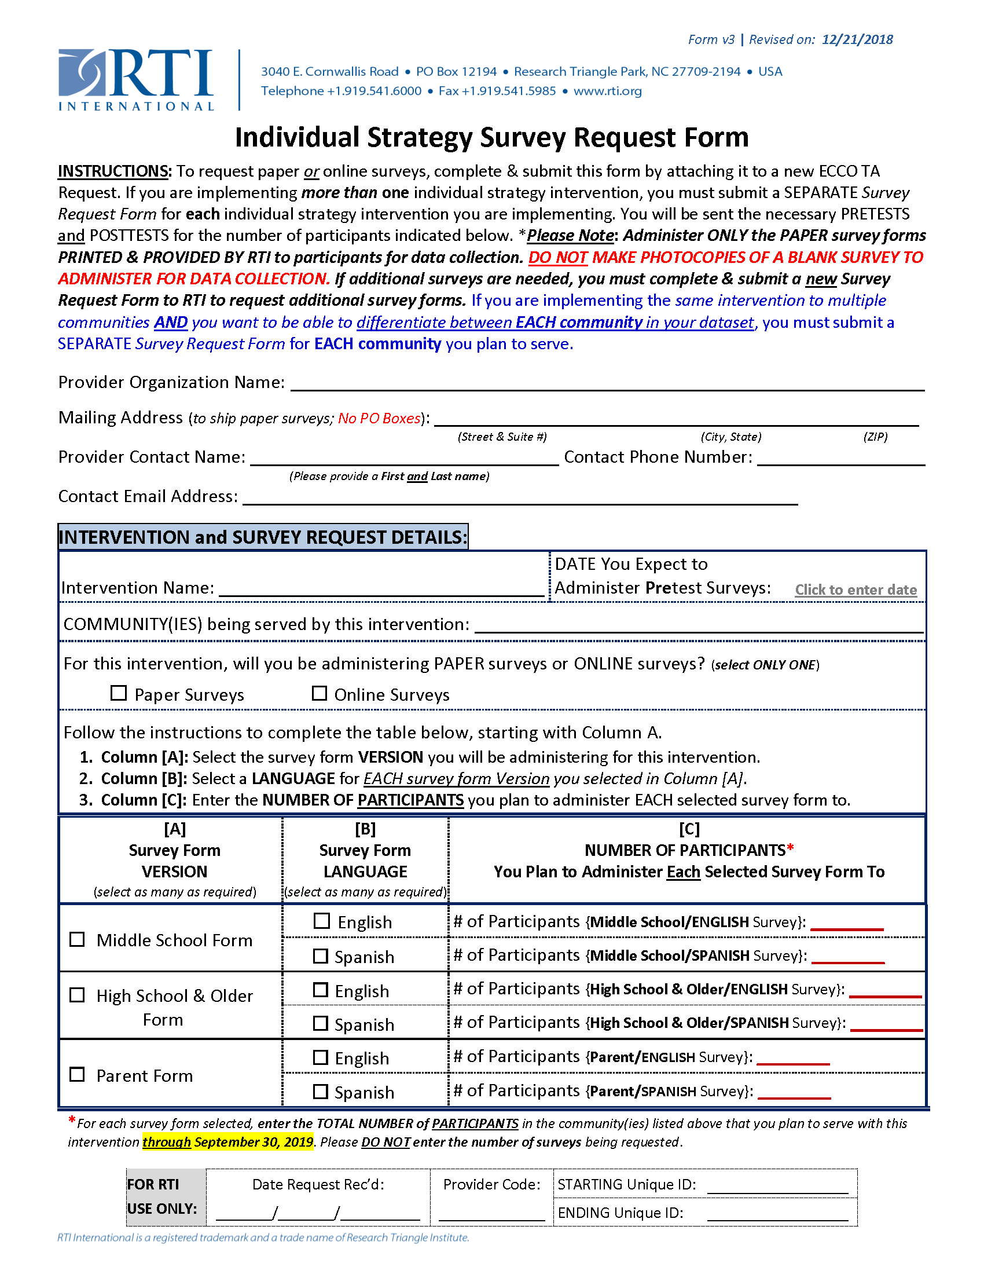

Appendix F  
Georgia Individual Strategy Survey—Middle School Pretest

The survey should NOT be copied

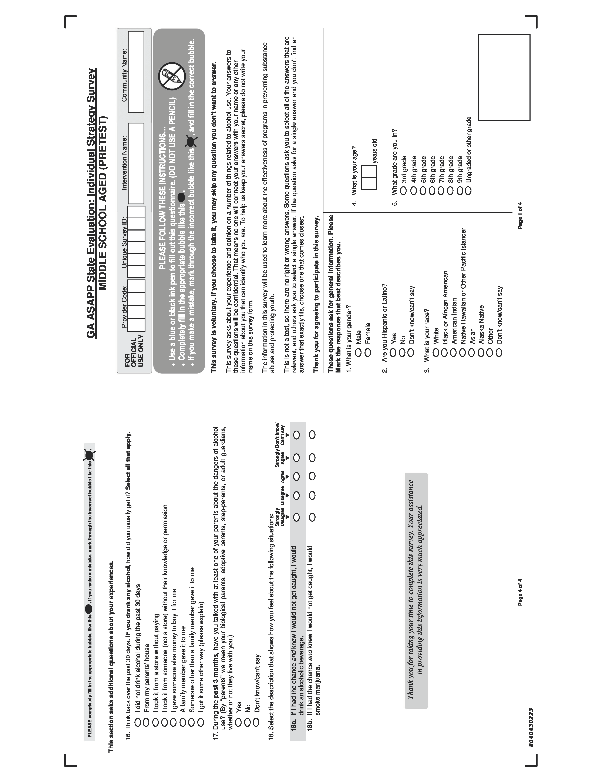

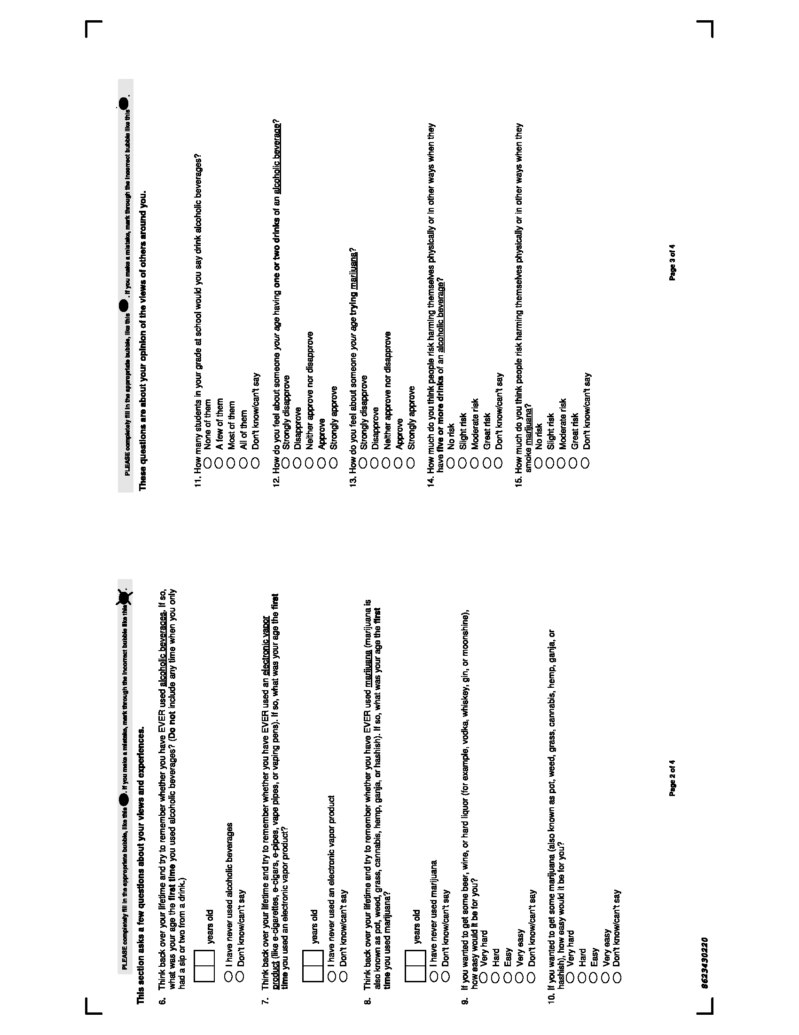

Appendix G  
Georgia Individual Strategy Survey—High School Pretest

The survey should NOT be copied

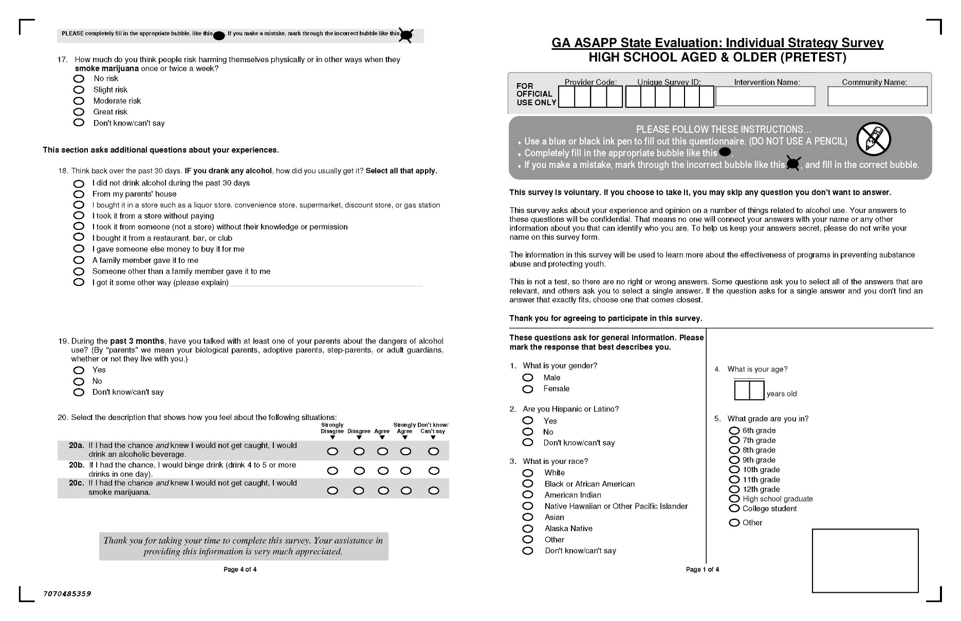

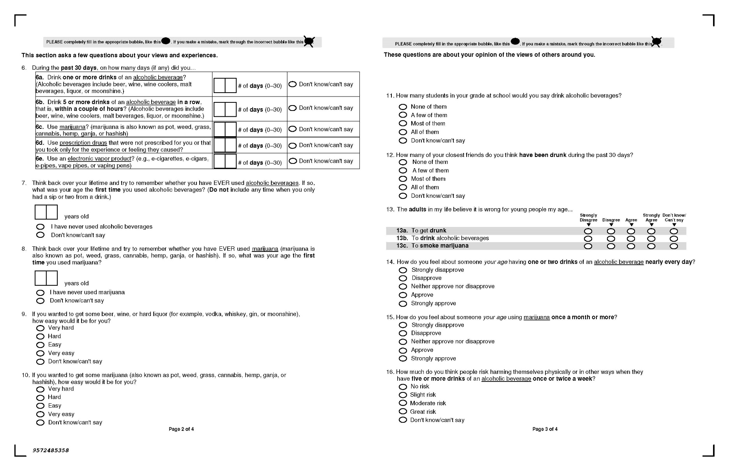

Appendix H  
Georgia Individual Strategy Survey—Parent Pretest

The survey should NOT be copied

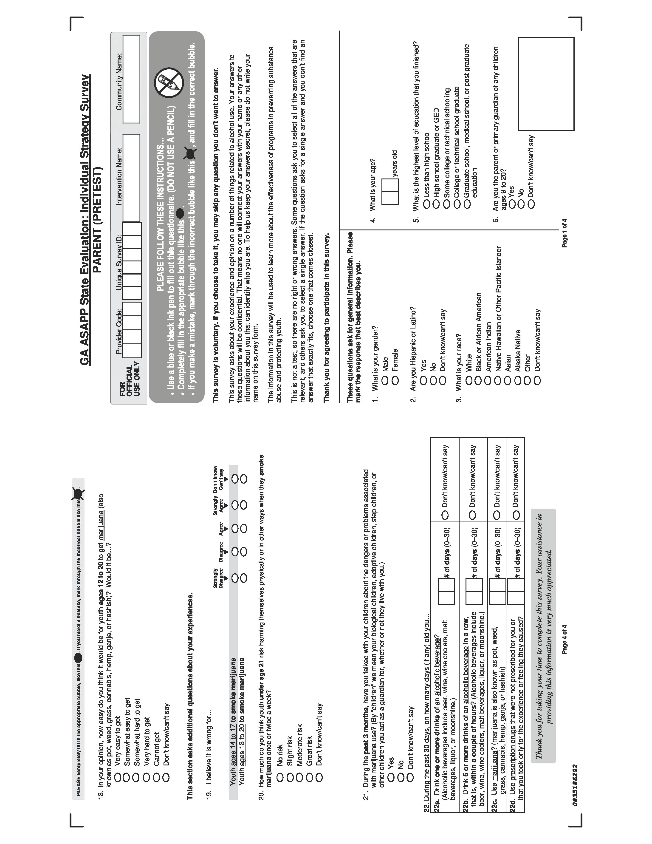

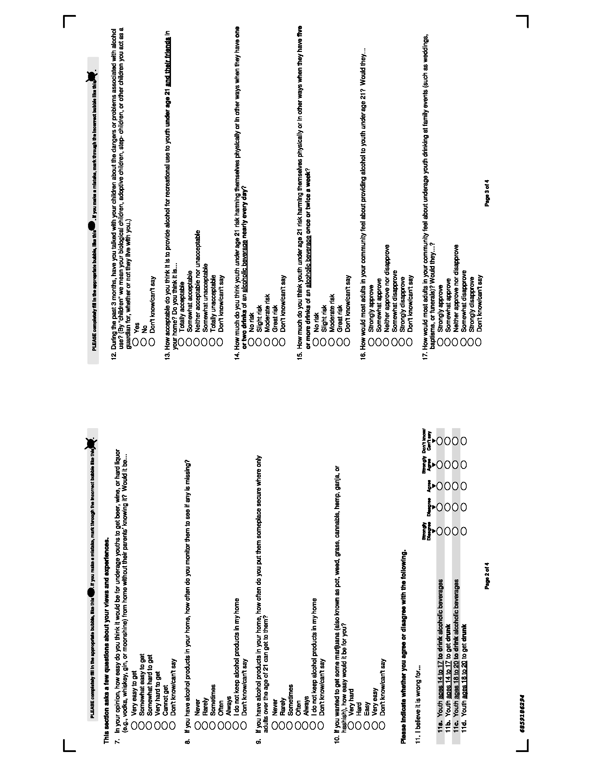

1. * If providers would like to have confirmation that their individual strategy surveys have been received by *RTI Data Capture* services, ***providers* must apply a tracking sticker to their package *OR* request a receipt confirmation for their package through their selected shipping entity** (e.g., USPS, FedEx, UPS, etc.) ***BEFORE mailing the package to RTI***.
   * Providers should ship completed pretest and posttest surveys to RTI in ***multiple* batches** **throughout the contract year**. *PLEASE AVOID MAILING A LARGE BATCH OF SURVEYS CLOSE TO THE END OF THE FISCAL YEAR (OR THE ESTABLISHED DEADLINE) – as doing so could cause major delays in the data scanning, cleaning, analysis, and reporting process.*
   * **The provider will decide on the shipping service/method and options** (e.g., via FedEx, UPS, USPS, adding package tracking, overnight shipping, etc.). We suggest providers use FedEx or UPS – as this method results in faster delivery (compared to USPS) and both companies automatically provide tracking numbers for packages. If providers choose to ship via USPS, it is advisable to send packages either “Certified Mail” or “Return Receipt Requested” so that providers can track packages and receive instant notification of delivery.

  