Opioid Misuse & Poisonings in the Central Service Area

Opioid analgesics are drugs that are usually prescribed to relieve pain and include: methadone, which is used to treat opioid dependency as well as pain; other opioids, such as oxycodone and hydrocodone; and synthetic narcotics such as fentanyl and propoxyphene. Opium, heroin, and cocaine are not included in this class. |  |  | In 2009, 15,597 people died nationally from overdoses involving prescription pain relievers such as oxycodone, hydrocodone, and methadone—a 109% increase since 2002. However, national estimates of past-year non-medical use of prescription pain relievers remained relatively stable since 2002.  A recent study found a significant increase in past-year non-medical use of pain relievers of 200 to 365 days between 2002-2003 and 2009-2010. Significant increases in rates of 200 to 365 days of use were since during that period for males and for persons age 18 to 49 years.³
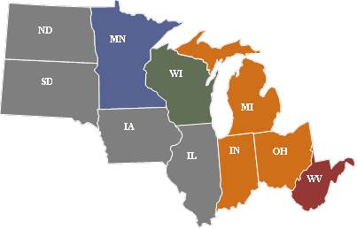 | ← Percentage of Past Year Non-Medical Pain Reliever Use among Adults Age 18+, 2008-2009 NSDUHs¹
≤4.0%

4.1% - 4.5%

4.6% - 5.0%

5.1% - 5.5%

5.6%+
From 1999 to 2006, the number of fatal poisonings within the United States involving opioid analgesics more than tripled, increasing from 4,000 to 13,800 deaths. In 2006, the rate of poisoning deaths involving opioid analgesics was higher for males, persons aged 35-54 years, and non-Hispanic white persons than for females and those in other age and racial/ethnic groups. In about half of the deaths involving opioid analgesics, more than one type of drug was specified as contributing to the death, with benzodiazepines contributing most frequently.²

One Central state, West Virginia, had an age-adjusted death rate for poisonings involving opioid analgesics that was significantly higher than the U.S. rate in 2006. Three Central states had age-adjusted death rates opioid poisonings that were significantly lower than the U.S. in 2006: Iowa, Indiana, and Minnesota.²

References
- Selected Drug Use, Perceptions of Great Risk, Average Annual Marijuana Initiates, Past Year Substance Dependence or Abuse, Needing But Not Receiving Treatment, and Past Year Mental Health Measures in the United States, by Age Group: Estimated Numbers (in Thousands), Annual Averages Based on 2008-2009 NSDUHs. Retrieved on July 11, 2012 from: http://www.oas.samhsa.gov/2k9State/WebOnlyTables/stateTabs.htm
- Warner M, Chen LH, Makuc DM. Increase in fatal poisonings involving opioid analgesics in the United States, 1999-2006. NCHS data brief, no 22. Hyattsville, MD: National Center for Health Statistics. 2009. Retrieved on July 11, 2012 from http://www.cdc.gov/nchs/data/databriefs/db22.pdf
- Division of Unintentional Injury Prevention, National Center for Injury Prevention and Control, Centers for Disease Control and Prevention. Frequency of prescription pain reliever nonmedical use: 2002-2003 and 2009-2010. Arch Intern Med Research Letter, published online June 25, 2012.

